# Q) Big data definition

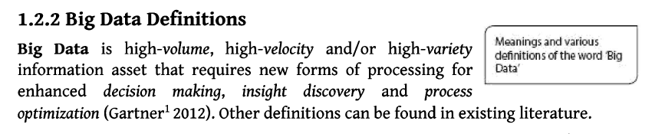 Q)Big Data characteristics.

5 V's of Big Data

* **Volume**
* **Veracity**
* **Variety**
* **Value**
* **Velocity**

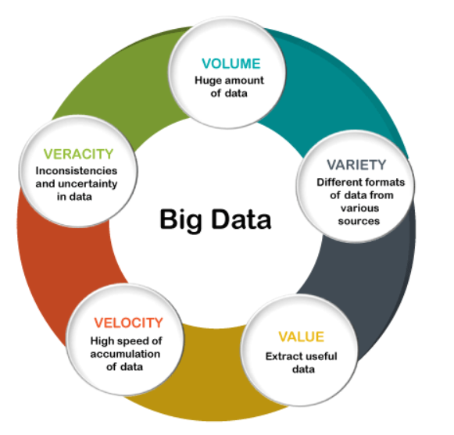

Volume

The name Big Data itself is related to an enormous size. Big Data is a vast 'volumes' of data generated from many sources daily, such as **business processes, machines, social media platforms, networks, human interactions,** and many more.

**Facebook** can generate approximately a **billion** messages, **4.5 billion** times that the "**Like**" button is recorded, and more than **350 million** new posts are uploaded each day. Big data technologies can handle large amounts of data.

Variety

Big Data can be **structured, unstructured, and semi-structured** that are being collected from different sources. Data will only be collected from **databases** and **sheets** in the past, But these days the data will comes in array forms, that are **PDFs, Emails, audios, SM posts, photos, videos,** etc.

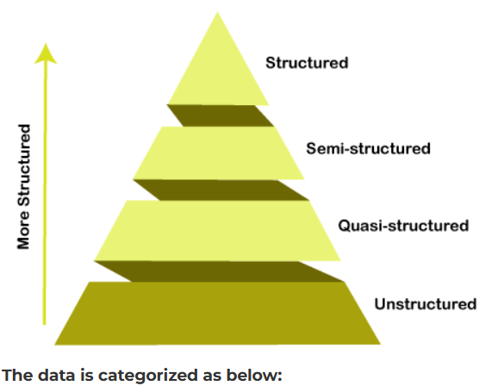

**The data is categorized as below:**

1. **Structured data:** In Structured schema, along with all the required columns. It is in a tabular form. Structured Data is stored in the relational database management system.
2. **Semi-structured:** In Semi-structured, the schema is not appropriately defined, e.g., **JSON, XML, CSV, TSV**, and **email**. OLTP (**Online Transaction Processing**) systems are built to work with semi-structured data. It is stored in relations, i.e., **tables**.
3. **Unstructured Data**: All the **unstructured files, log files, audio files**, and **image** files are included in the unstructured data. Some organizations have much data available, but they did not know how to **derive** the value of data since the data is raw.
4. **Quasi-structured Data:**The data format contains textual data with inconsistent data formats that are formatted with effort and time with some tools.

Veracity

Veracity means how much the data is reliable. It has many ways to filter or translate the data. Veracity is the process of being able to handle and manage data efficiently. Big Data is also essential in business development.

For example, **Facebook posts** with hashtags.

Value

Value is an essential characteristic of big data. It is not the data that we process or store. It is **valuable** and **reliable** data that we **store, process**, and also **analyze**.

# Q) Big Data Types

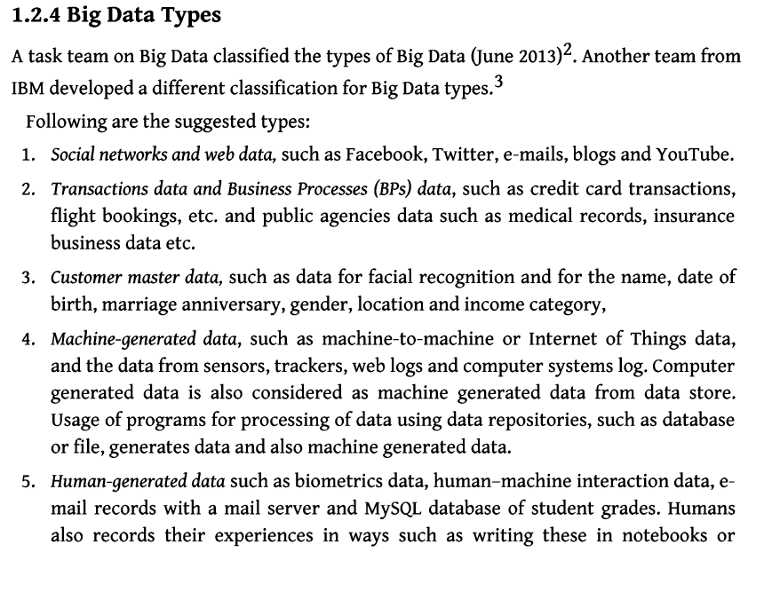

# Q) Big data Classification

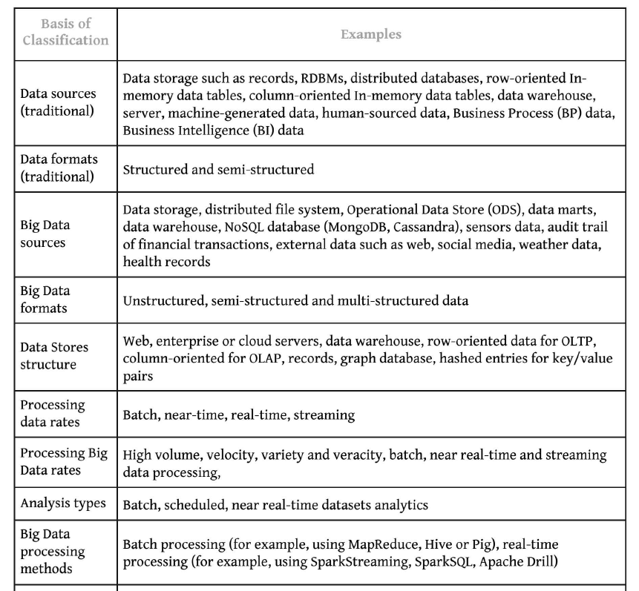

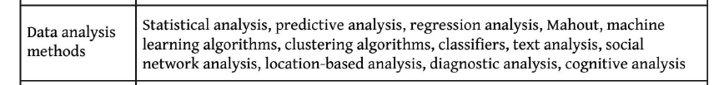

# Q: Scalability and Parallel Processing

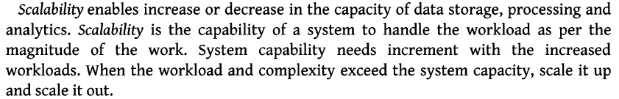

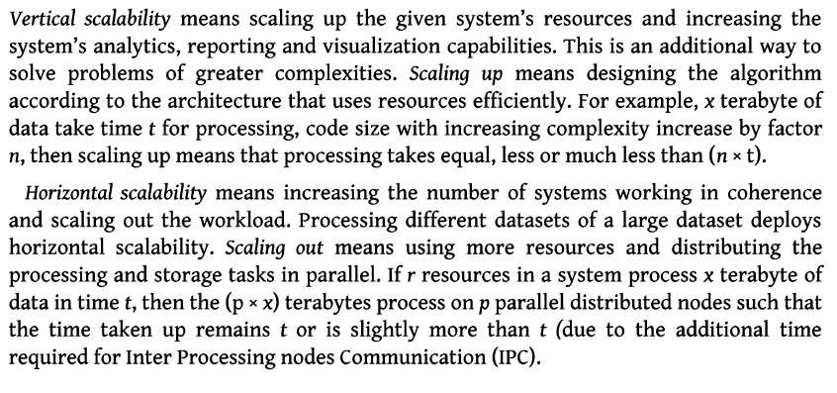

# Q. Designing Data Architecture

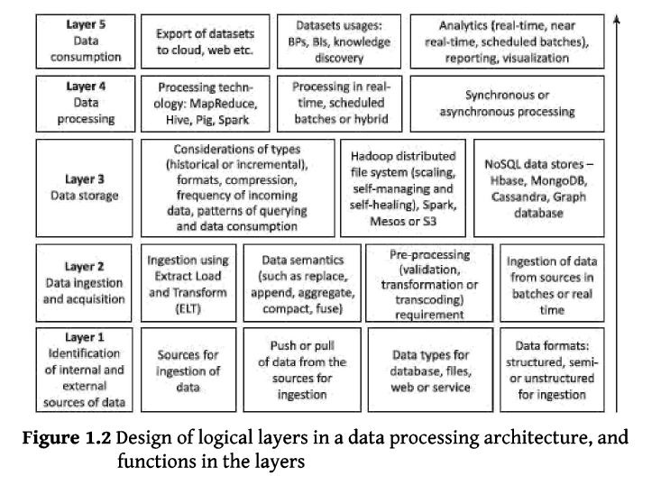

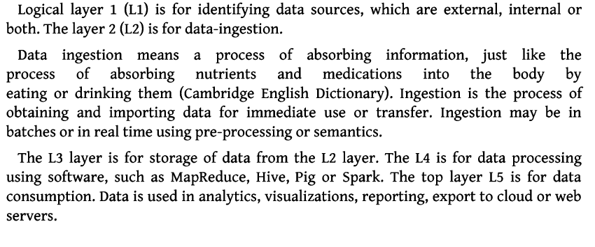

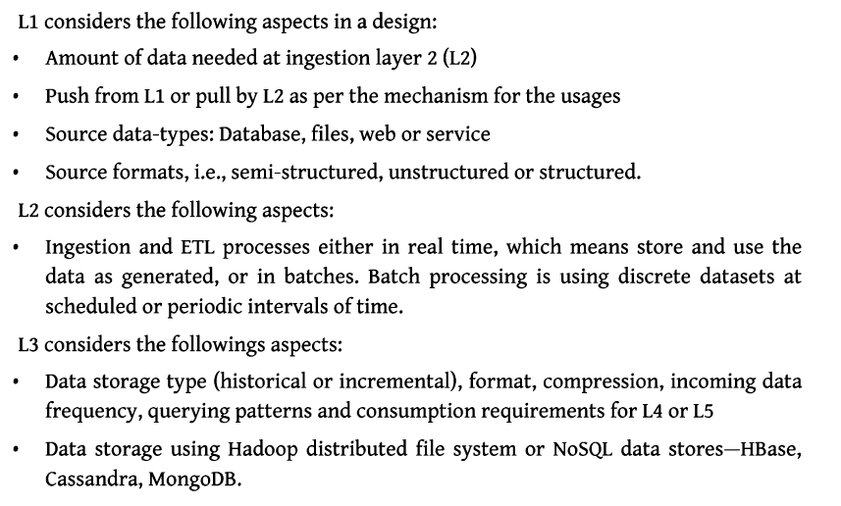

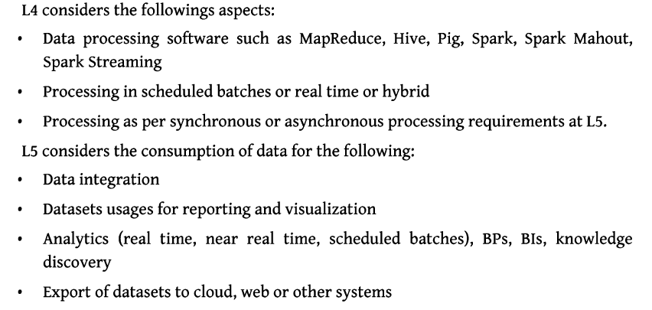

# Q. Data Sources and Analysis

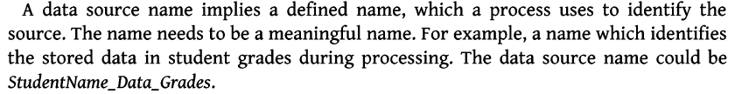

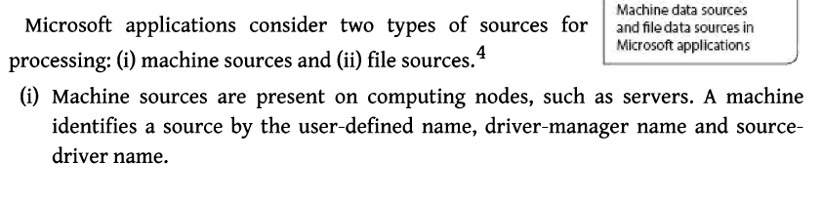

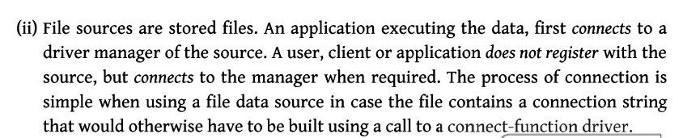

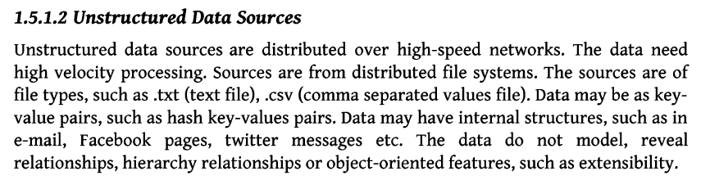

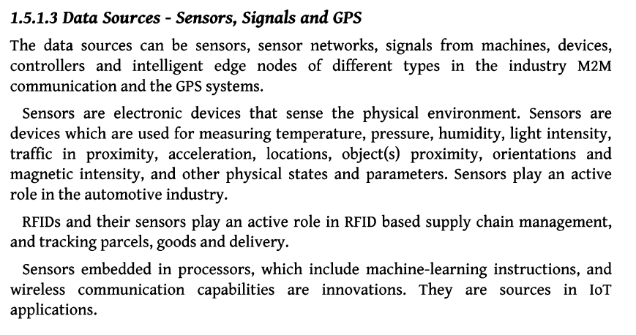

# Q ) Quality

Definition

Data with five R’s as follows

**Relavancy, recency, range, robustness and reliability , Relevancy is of outmost importance**

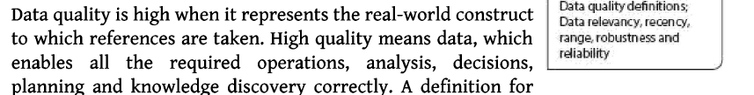

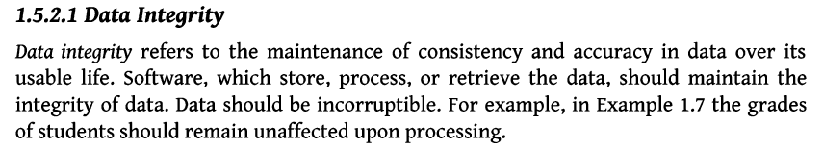

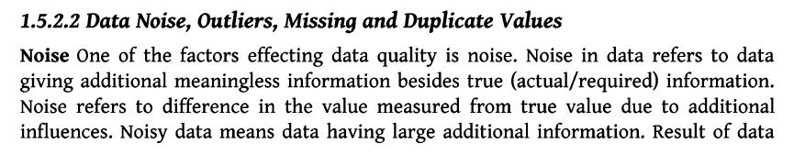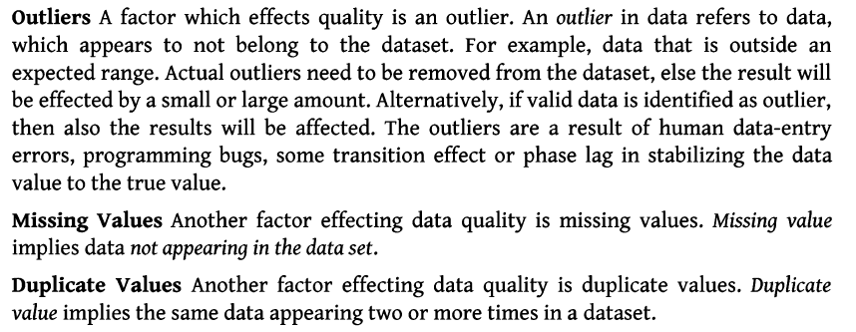

# Q) Preprocessing and Storing

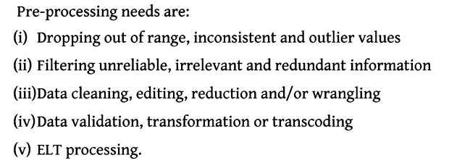

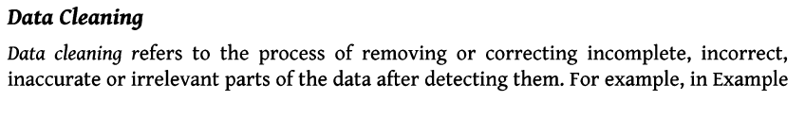

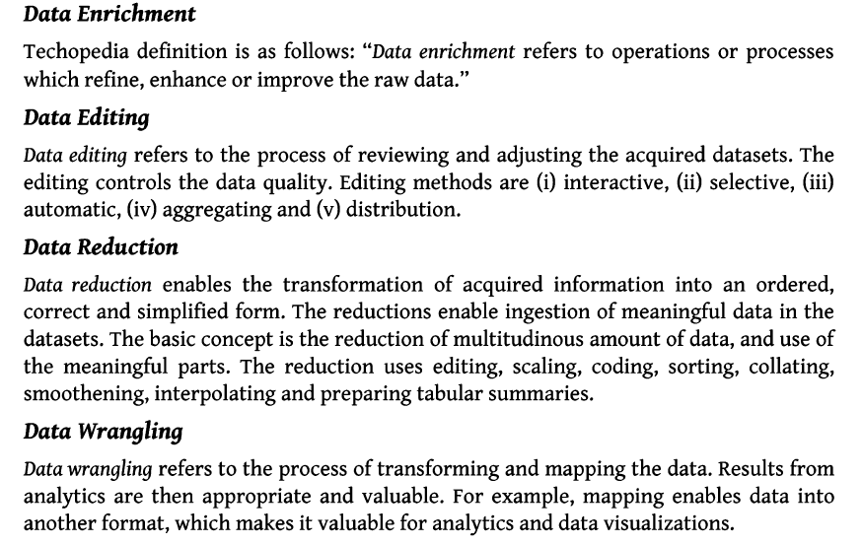

# q) Data Storage and analysis

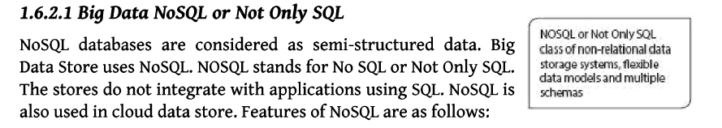

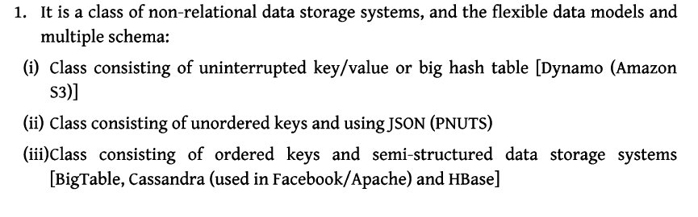

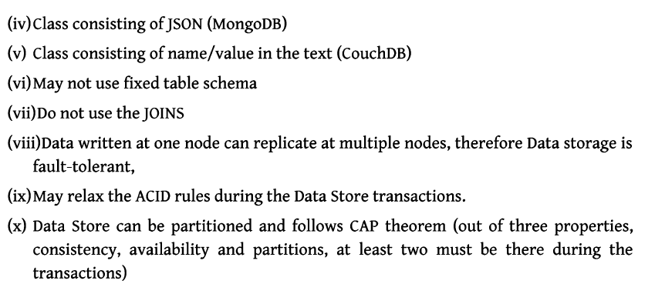

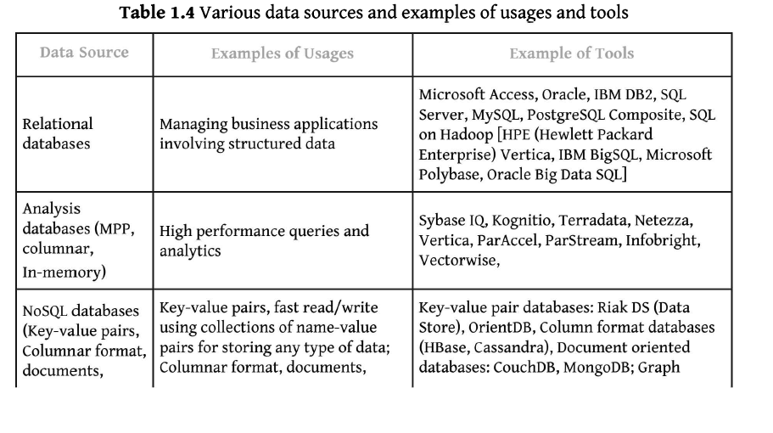

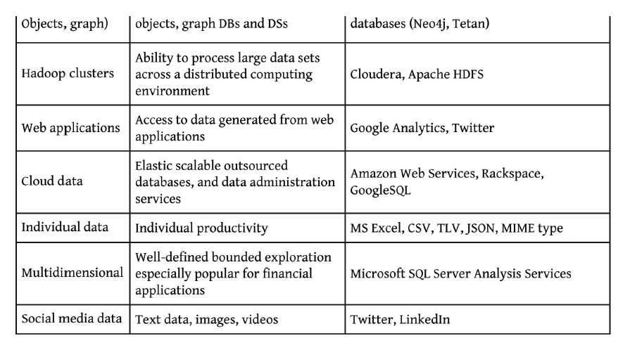

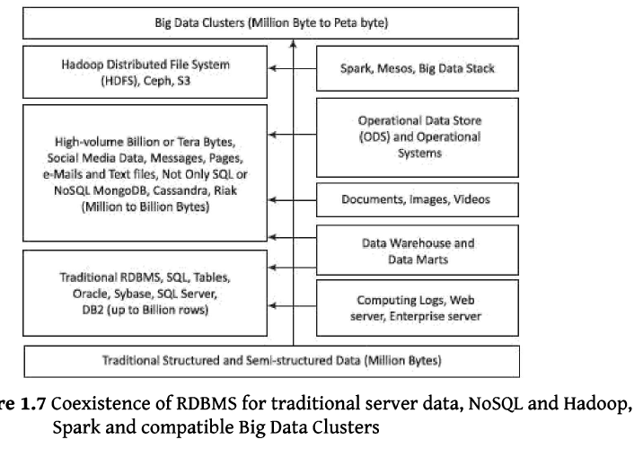

# Q) Big data analytics case studies

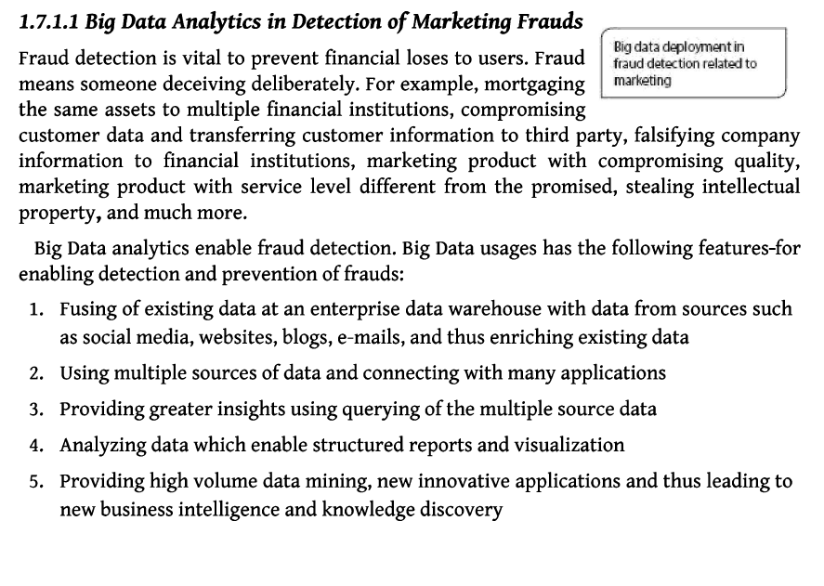

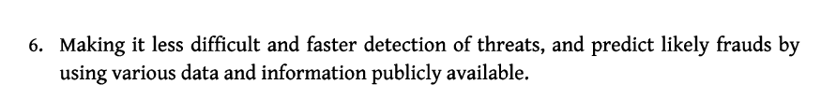

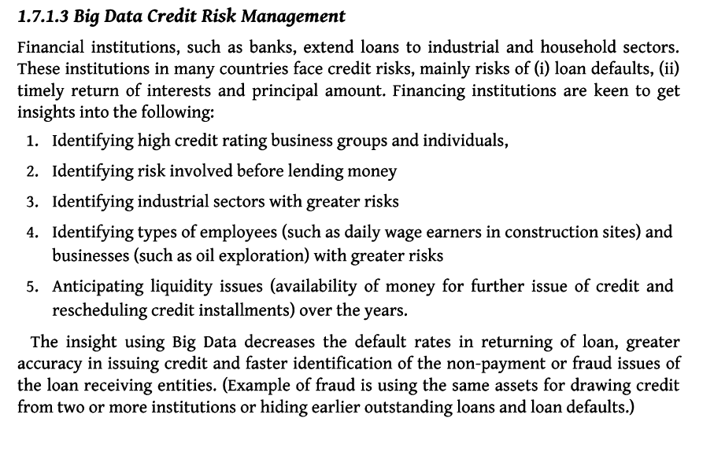

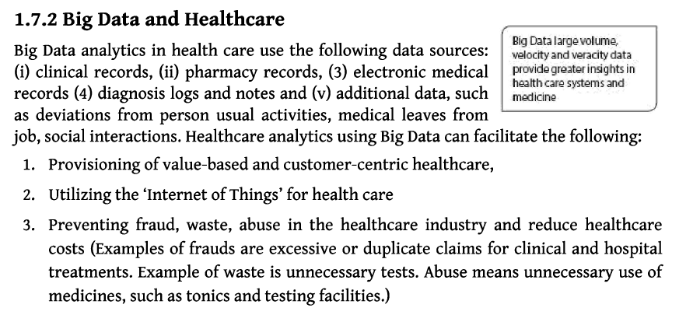

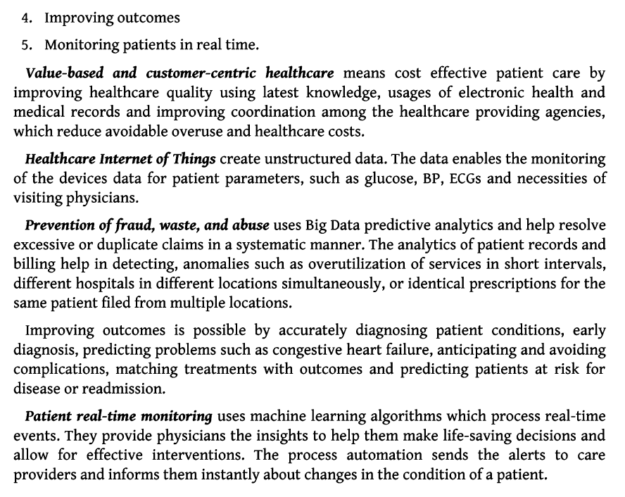

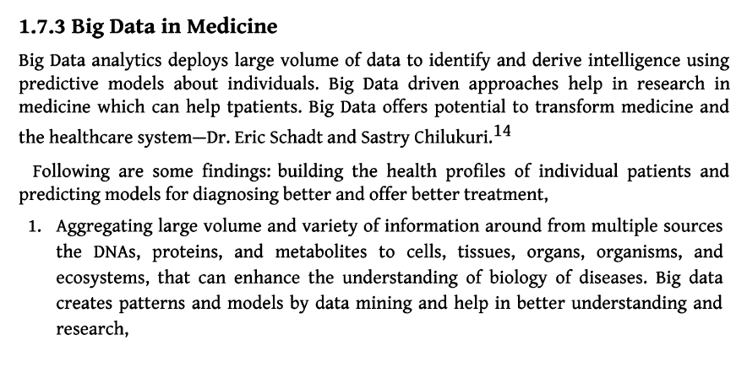

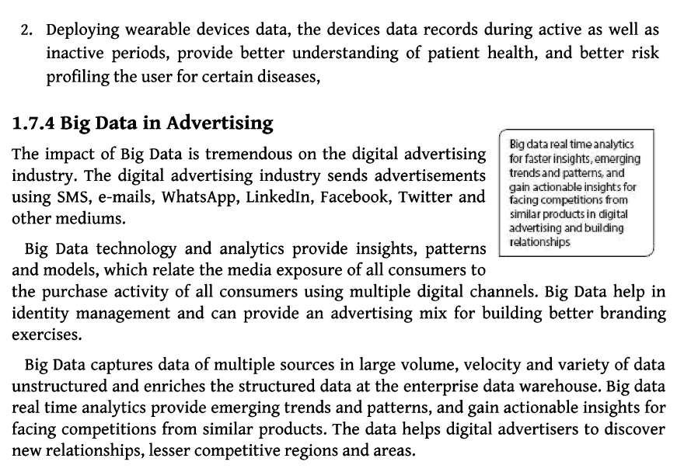

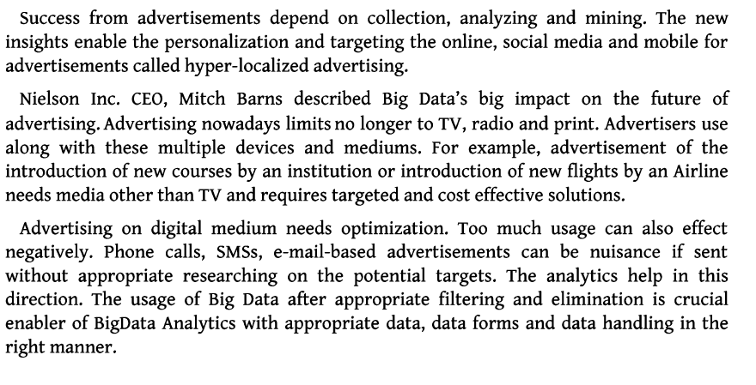

UNIT -II

# Q) Hadoop and Its Eco System

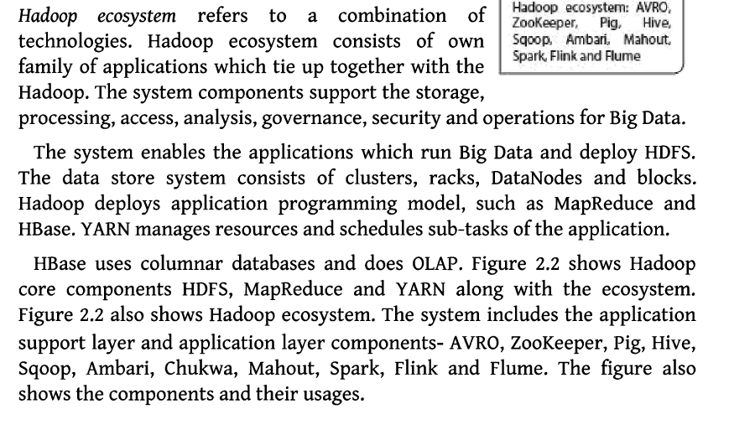

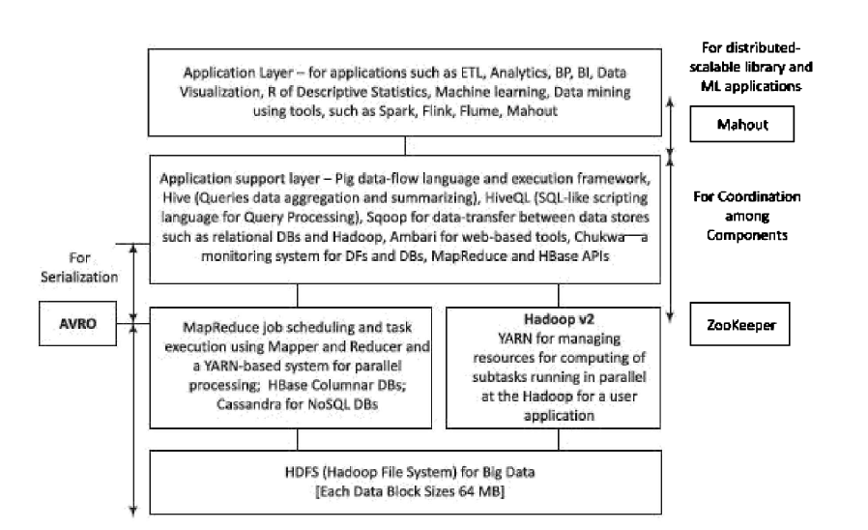

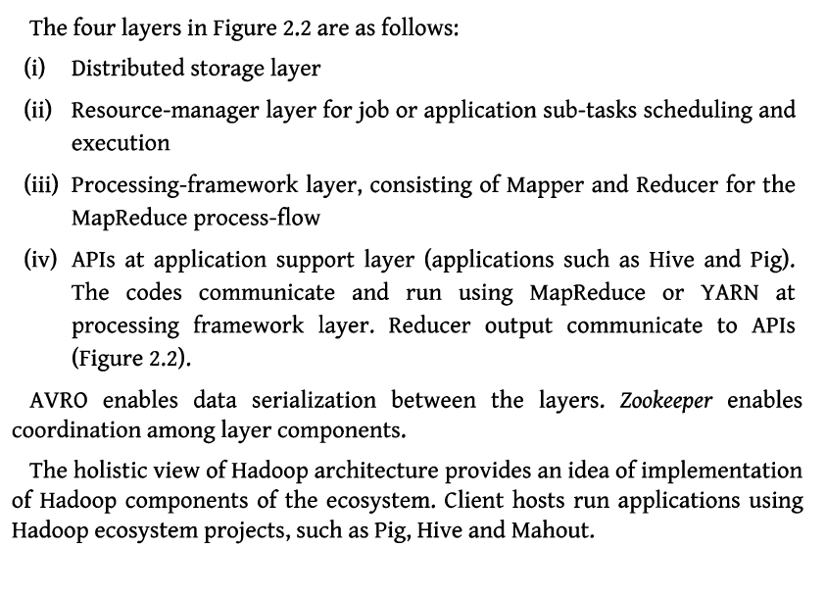

# Q) Hadoop Distributed File System

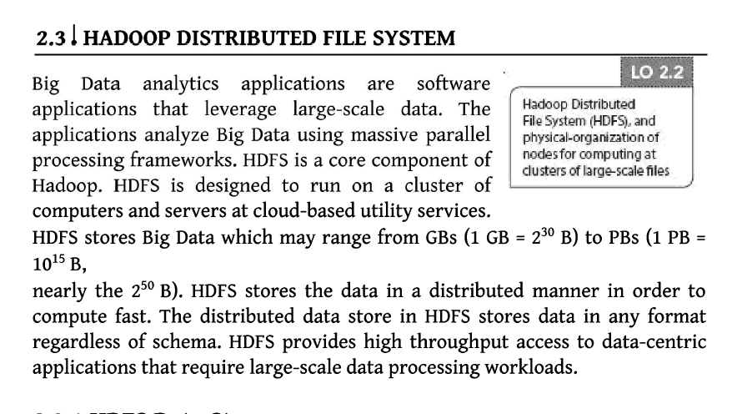

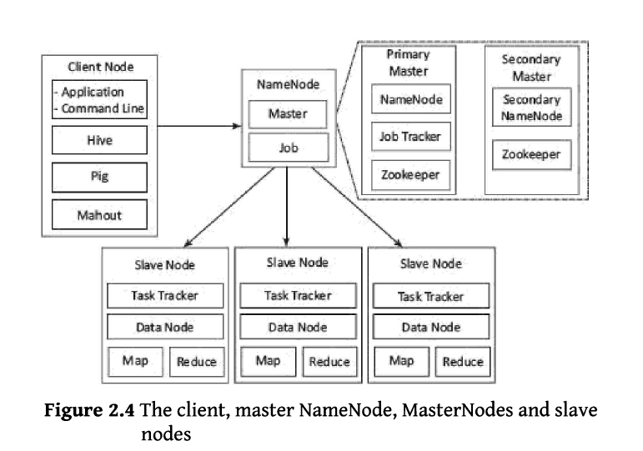

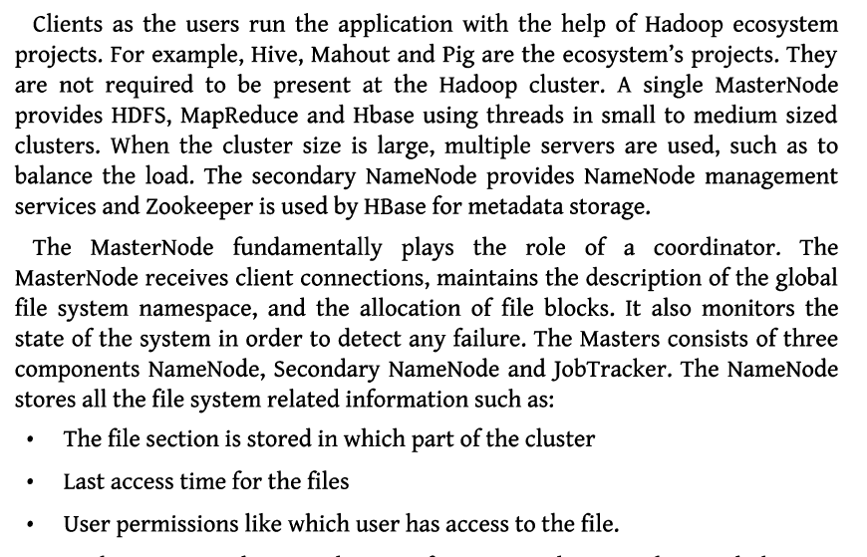

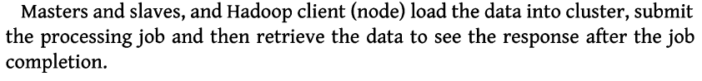

Q) Map Reduce Framework and programming Model

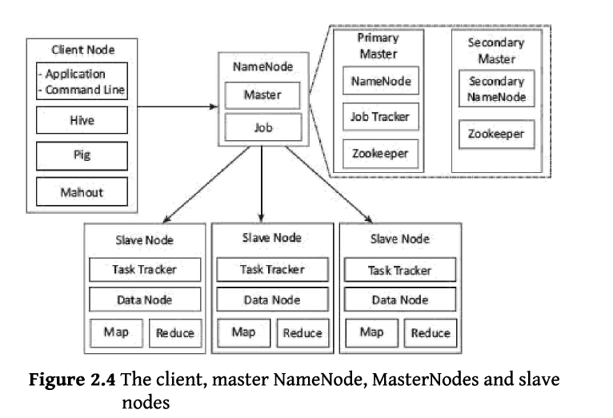

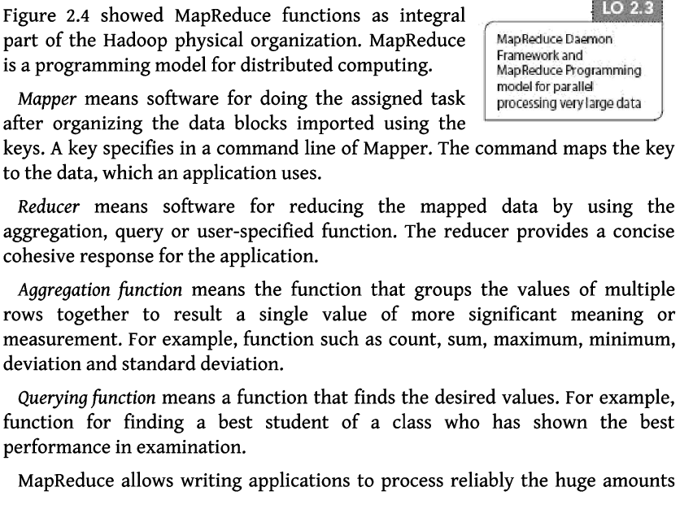

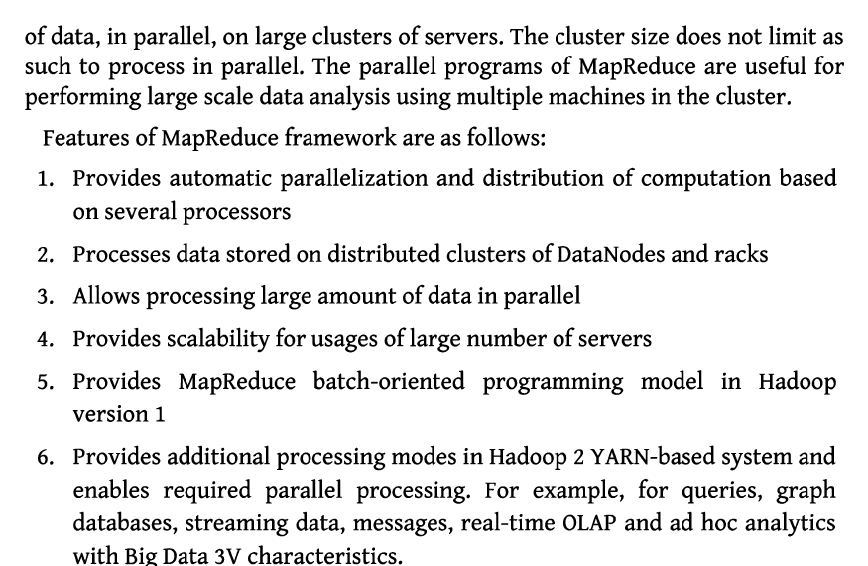

Example:

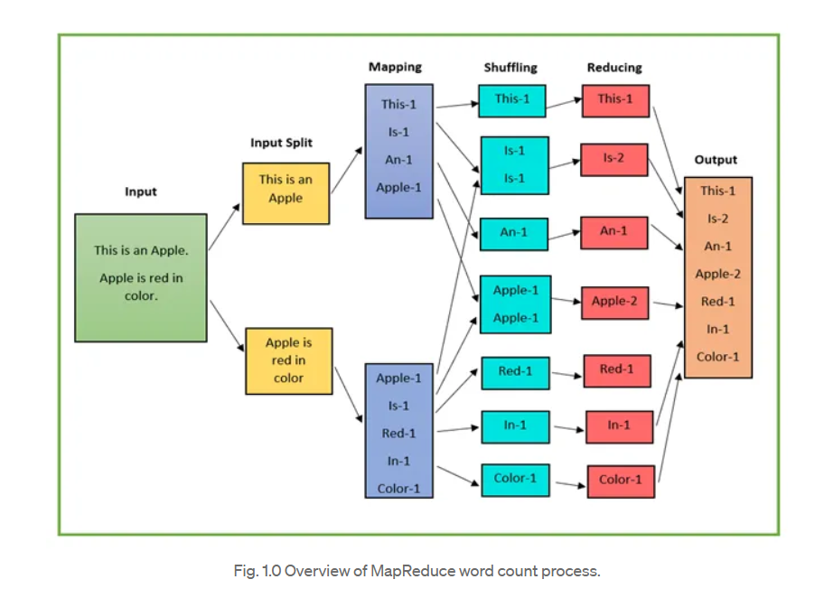

# Q) Hadoop Yarn

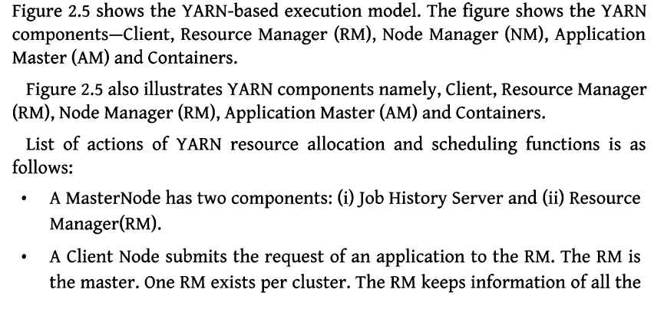

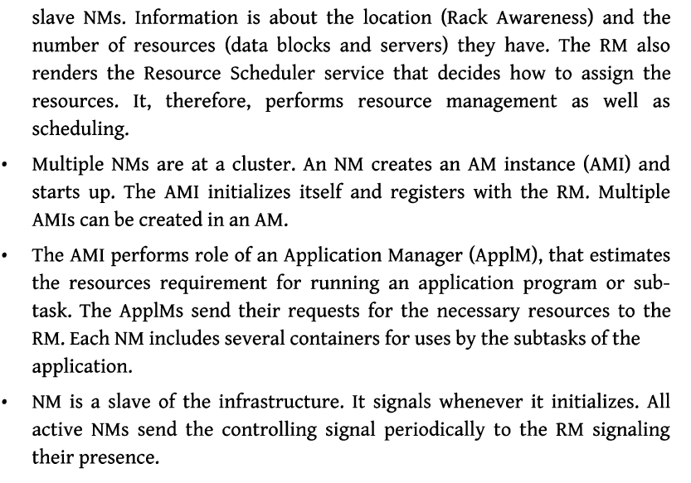

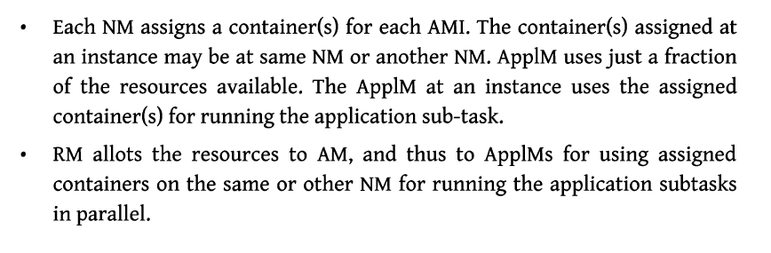

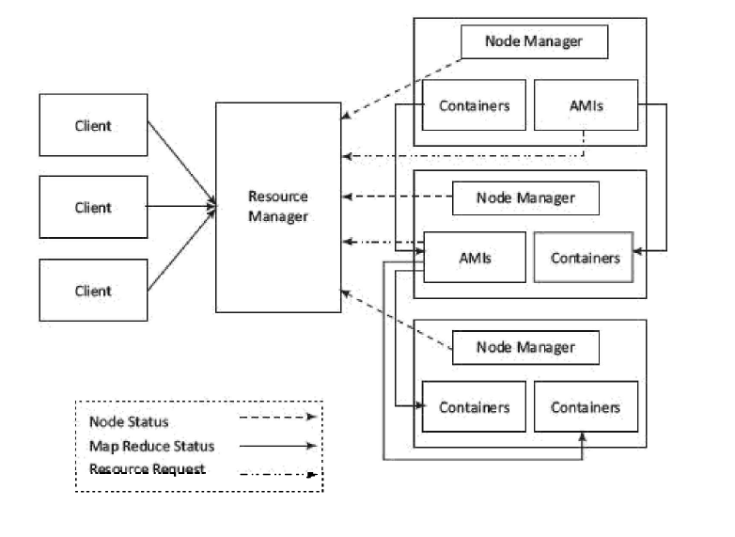

# Q) Hadoop Eco System Tools

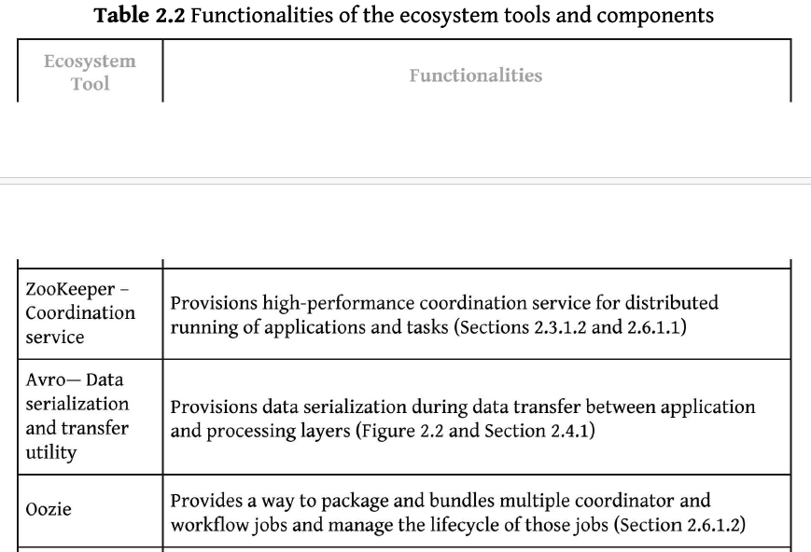

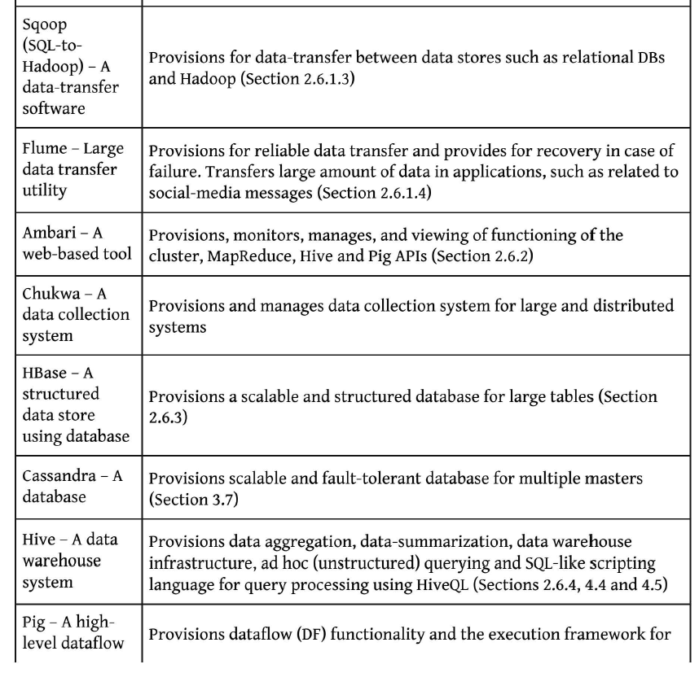

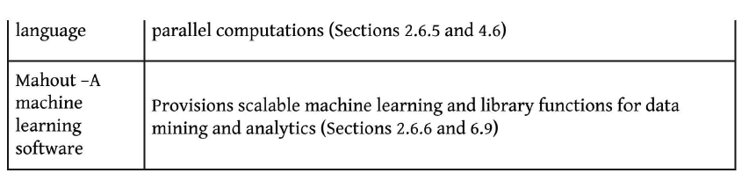

# Q) HDFS Design Features

1. **Fault tolerance**. HDFS has been designed to detect faults and automatically recover quickly ensuring continuity and reliability.
2. **Speed**, because of its cluster architecture, it can maintain 2 GB of data per second.
3. **Access to more types of data**, specifically Streaming data. Because of its design to handle large amounts of data for batch processing it allows for high data throughput rates making it ideal to support streaming data.
4. **Compatibility and portability**. HDFS is designed to be portable across a variety of hardware setups and compatible with several underlying operating systems ultimately providing users optionality to use HDFS with their own tailored setup. These advantages are especially significant when dealing with big data and were made possible with the particular way HDFS handles data.

This graph demonstrates the difference between a local file system and HDFS.

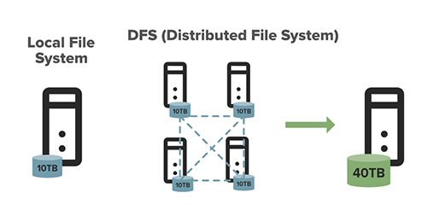

1. **Scalable**. You can scale resources according to the size of your file system. HDFS includes vertical and horizontal scalability mechanisms.
2. **Data locality**. When it comes to the Hadoop file system, the data resides in data nodes, as opposed to having the data move to where the computational unit is. By shortening the distance between the data and the computing process, it decreases network congestion and makes the system more effective and efficient.
3. **Cost effective**. Initially, when we think of data we may think of expensive hardware and hogged bandwidth. When hardware failure strikes, it can be very costly to fix. With HDFS, the data is stored inexpensively as it's virtual, which can drastically reduce file system metadata and file system namespace data storage costs. What's more, because HDFS is open source, businesses don't need to worry about paying a licensing fee.
4. **Stores large amounts of data**. Data storage is what HDFS is all about - meaning data of all varieties and sizes - but particularly large amounts of data from corporations that are struggling to store it. This includes both structured and unstructured data.
5. **Flexible**. Unlike some other more traditional storage databases, there's no need to process the data collected before storing it. You're able to store as much data as you want, with the opportunity to decide exactly what you'd like to do with it and how to use it later. This also includes unstructured data like text, videos and images.

# Q) HDFS User Commands

|  |  |
| --- | --- |
| **Command** | **Description** |
| -rm | Removes file or directory |
| -ls | Lists files with permissions and other details |
| -mkdir | Creates a directory named path in HDFS |
| -cat | Shows contents of the file |
| -rmdir | Deletes a directory |
| -put | Uploads a file or folder from a local disk to HDFS |
| -rmr | Deletes the file identified by path or folder and subfolders |
| -get | Moves file or folder from HDFS to local file |
| -count | Counts number of files, number of directory, and file size |
| -df | Shows free space |
| -getmerge | Merges multiple files in HDFS |
| -chmod | Changes file permissions |
| -copyToLocal | Copies files to the local system |
| -Stat | Prints statistics about the file or directory |
| -head | Displays the first kilobyte of a file |
| -usage | Returns the help for an individual command |
| -chown | Allocates a new owner and group of a file |

# Q) Apache Pig

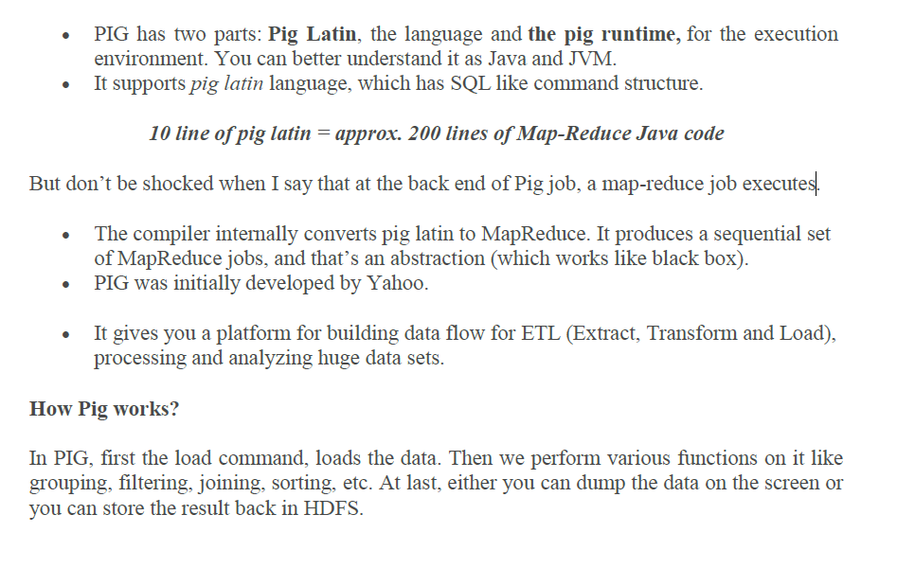

# Q) HIVE

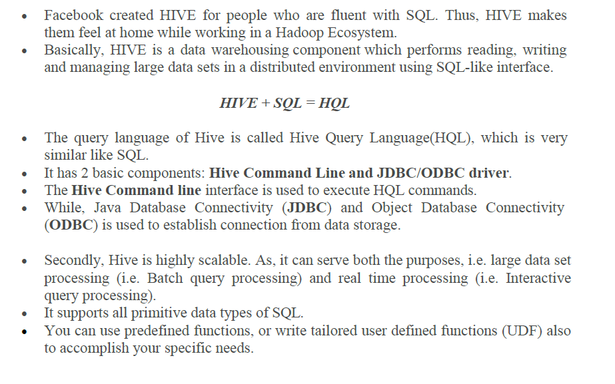

# Q) Sqoop

The major difference between Flume and Sqoop is that:

* Flume only ingests unstructured data or semi-structured data into HDFS.
* While Sqoop can import as well as export structured data from RDBMS or Enterprise

data warehouses to HDFS or vice versa.

Let us understand how Sqoop works using the below diagram:

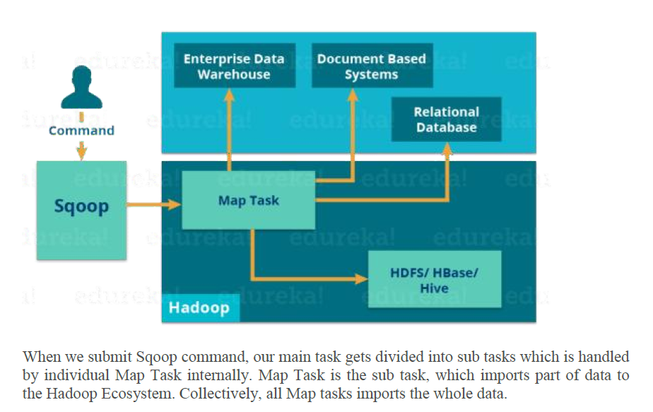

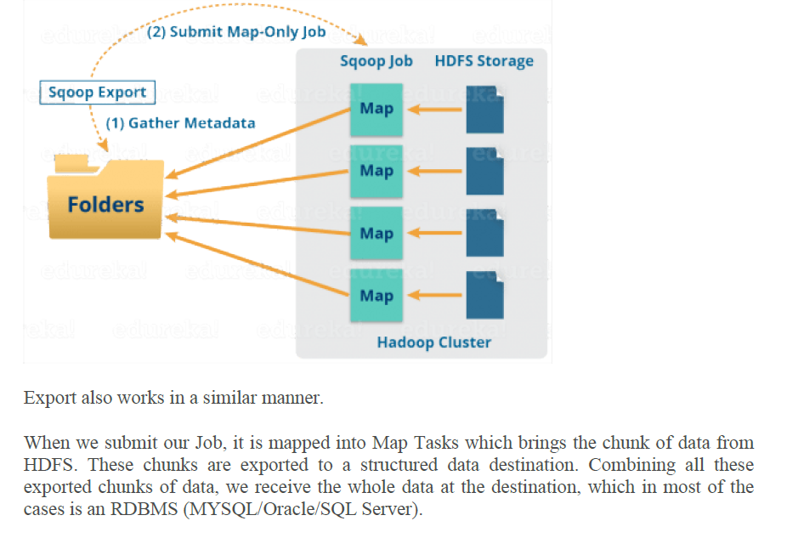

# Q)Flume

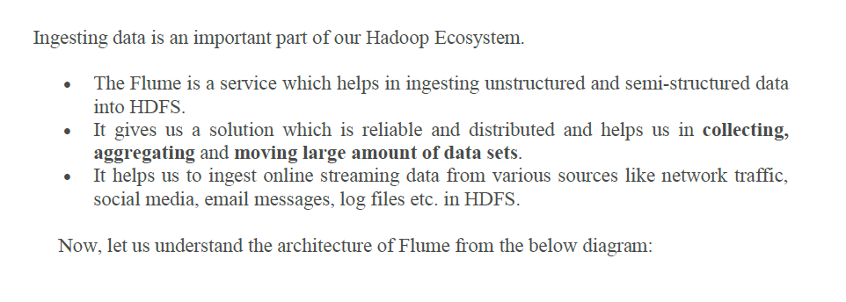

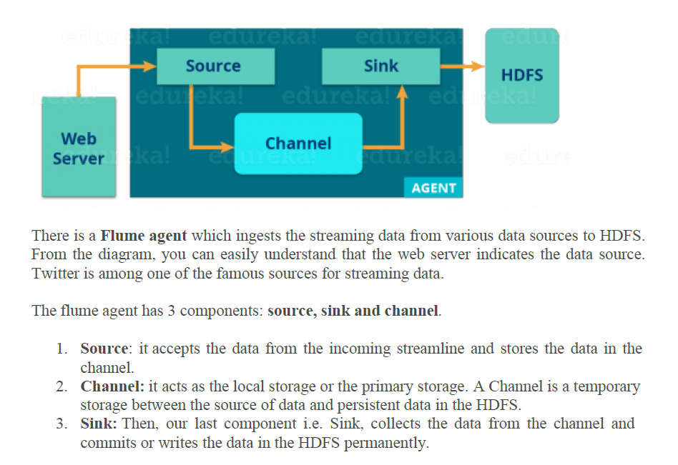

# Q)Oozie

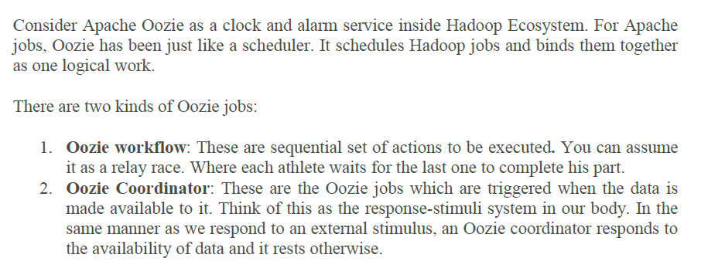

# Q)HBase

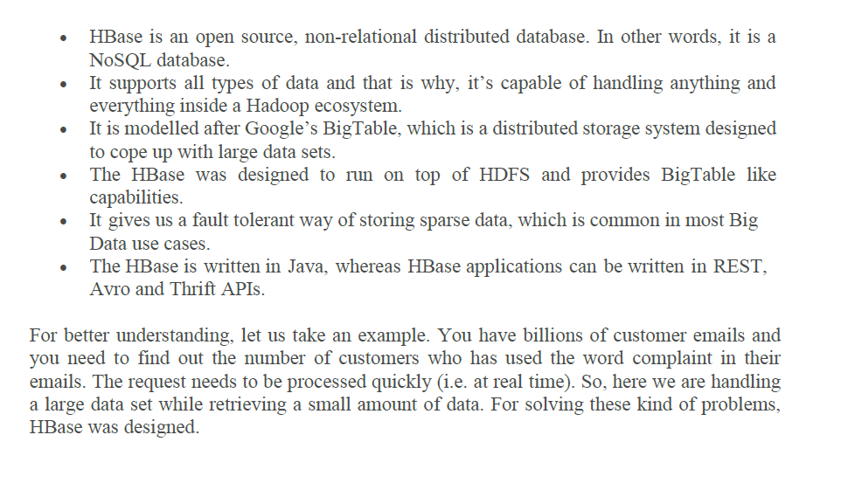

UNIT-III

# Q) Map Reduce Task

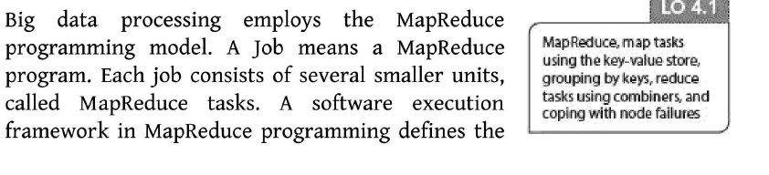

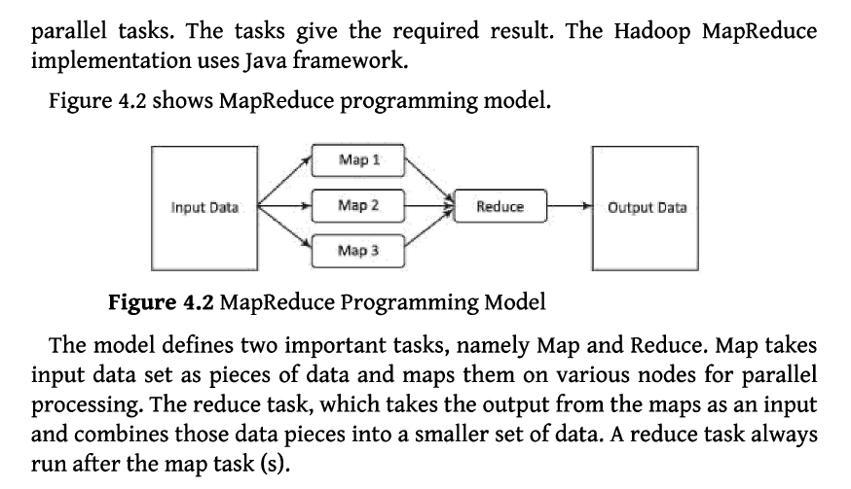

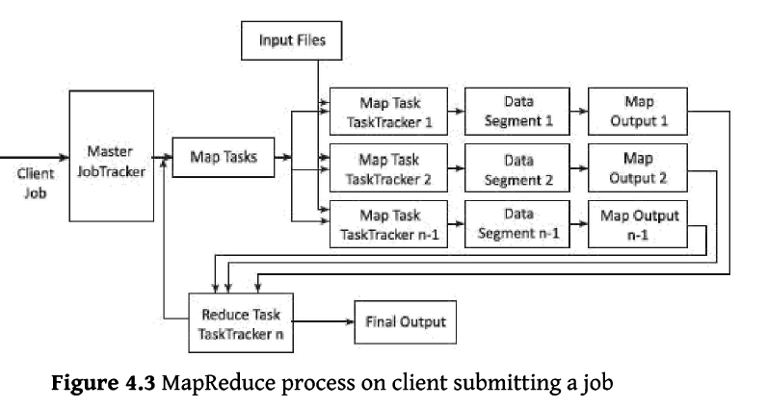

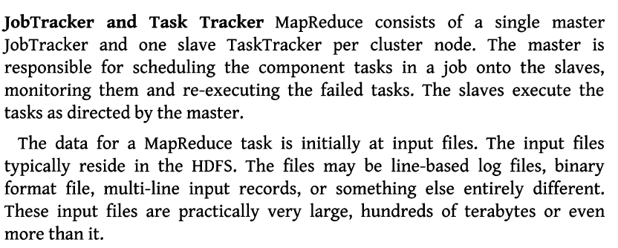

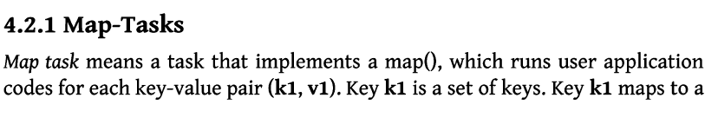

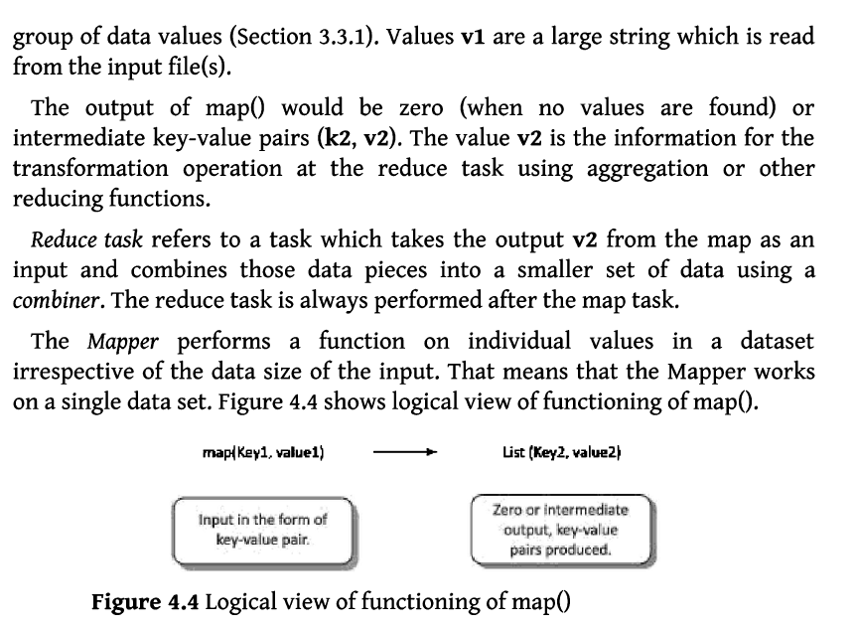

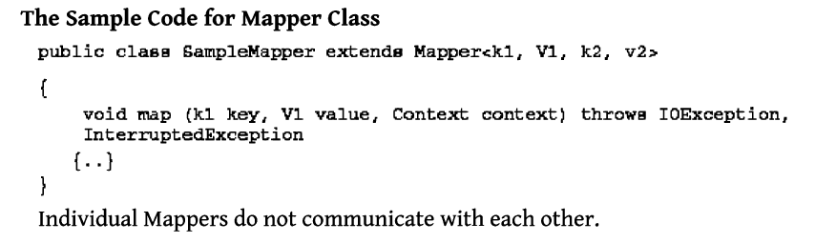

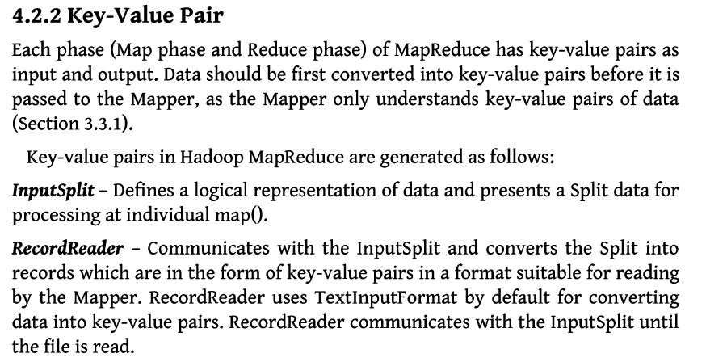

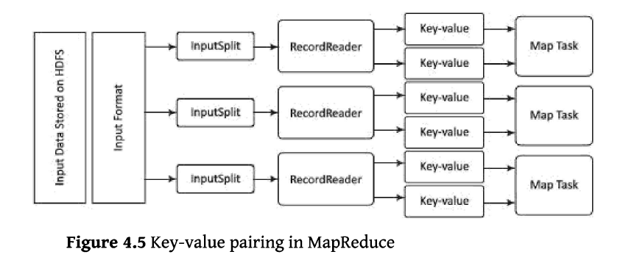

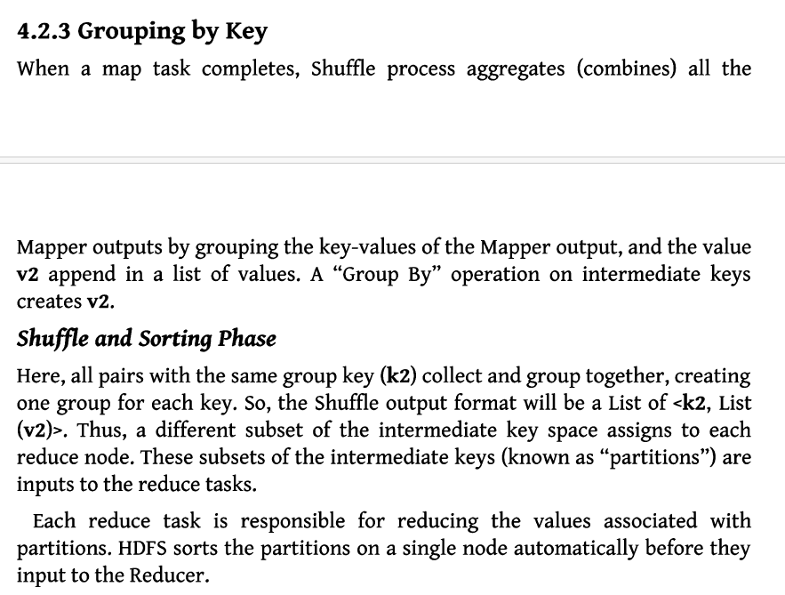

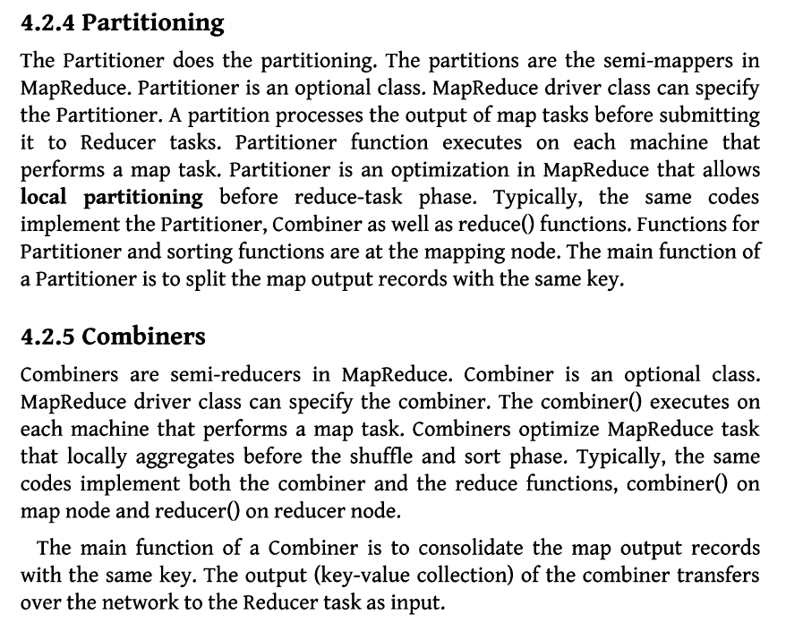

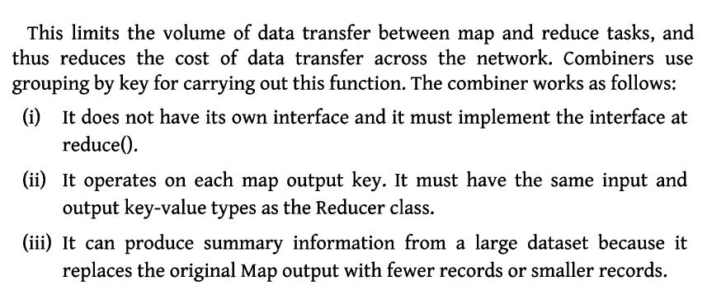

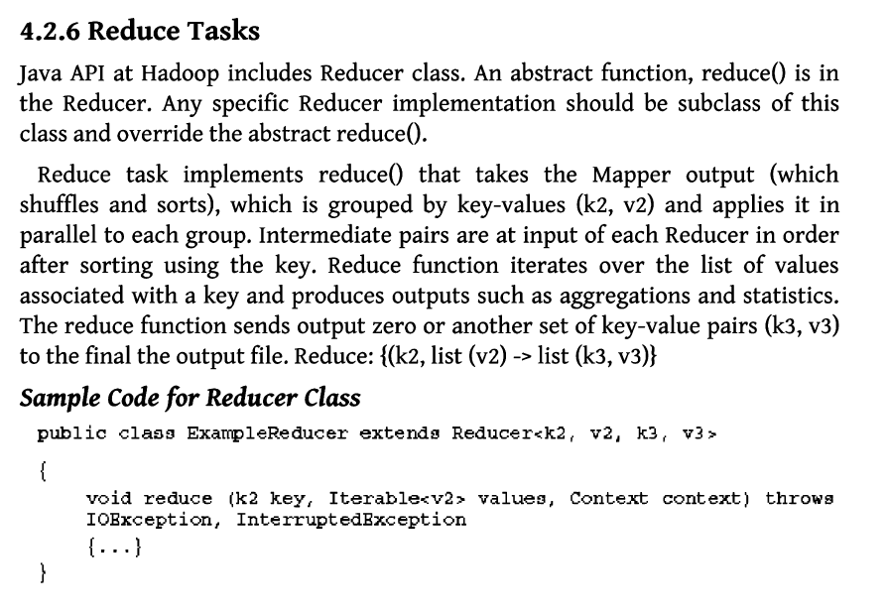

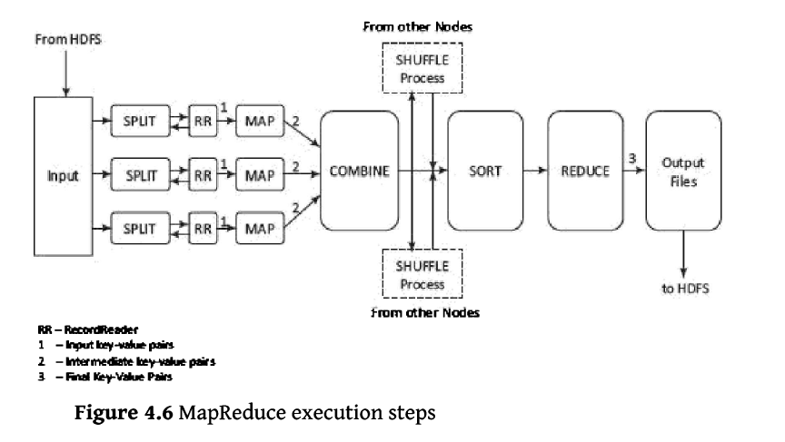

# Q) Composing the Map Reduce for Calculations and Algorithms

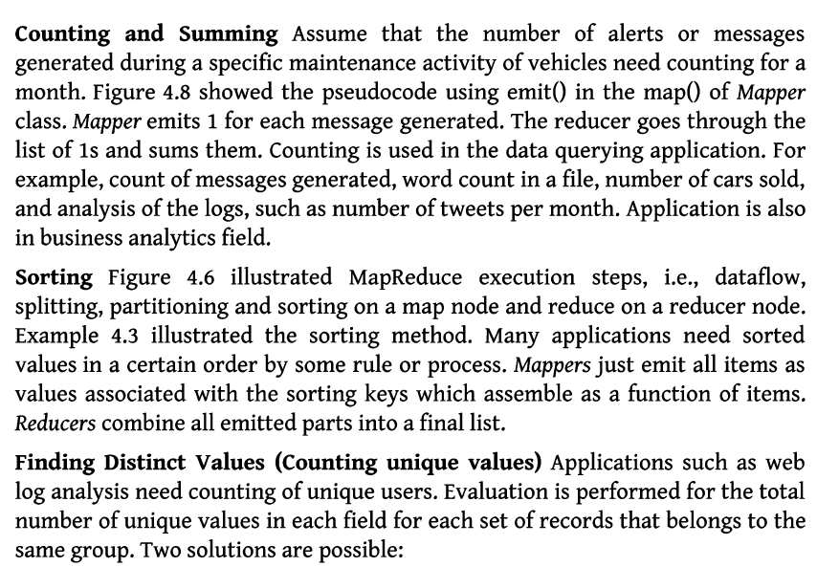

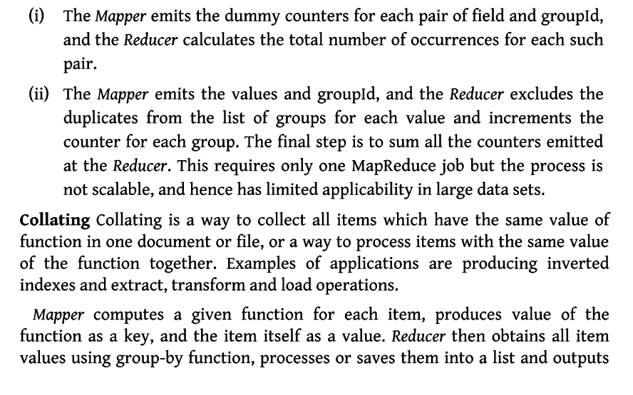

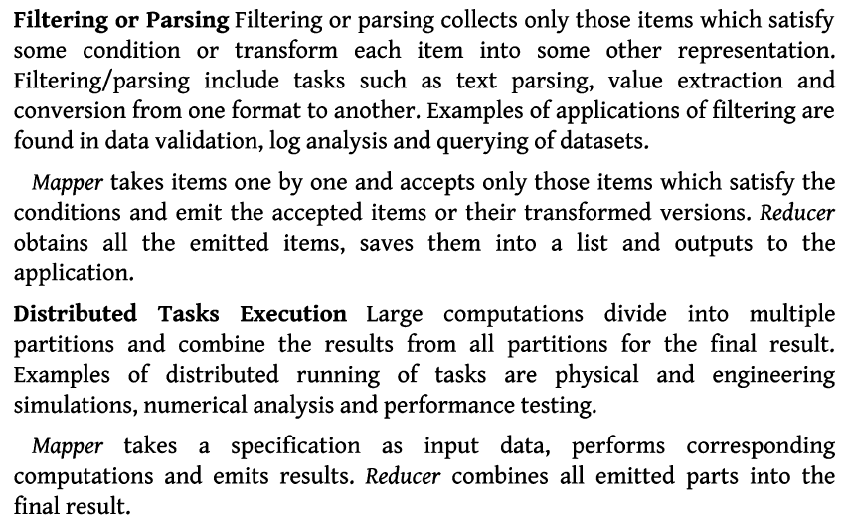

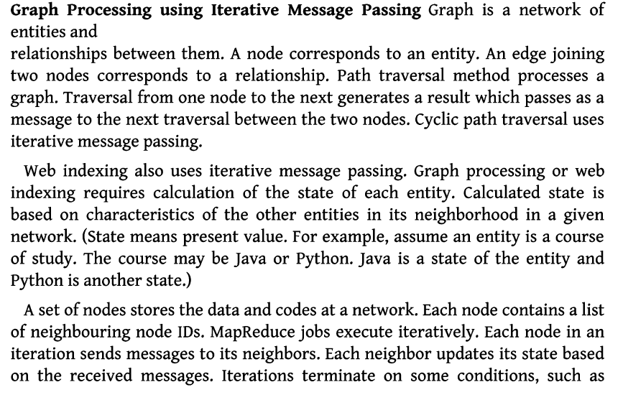

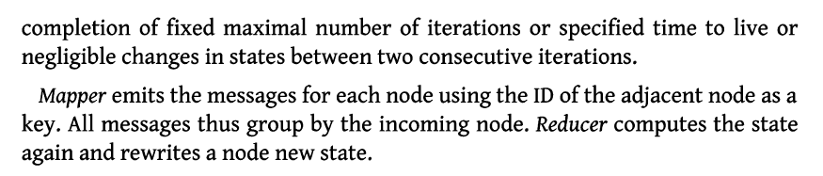

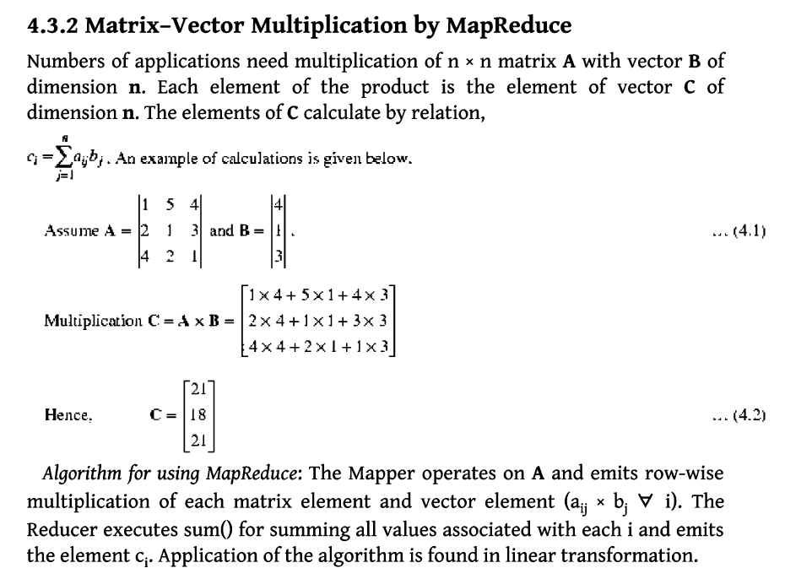

# Q) HIVE

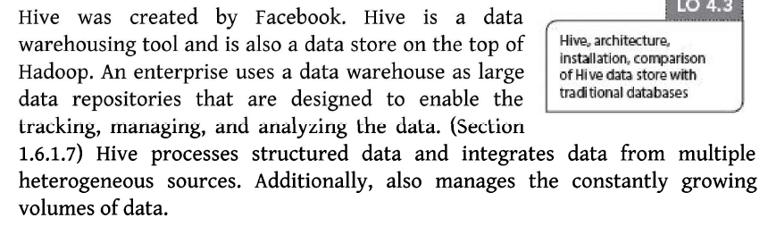

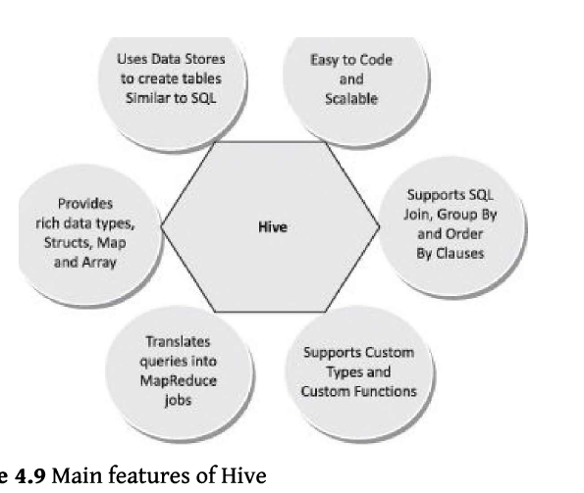

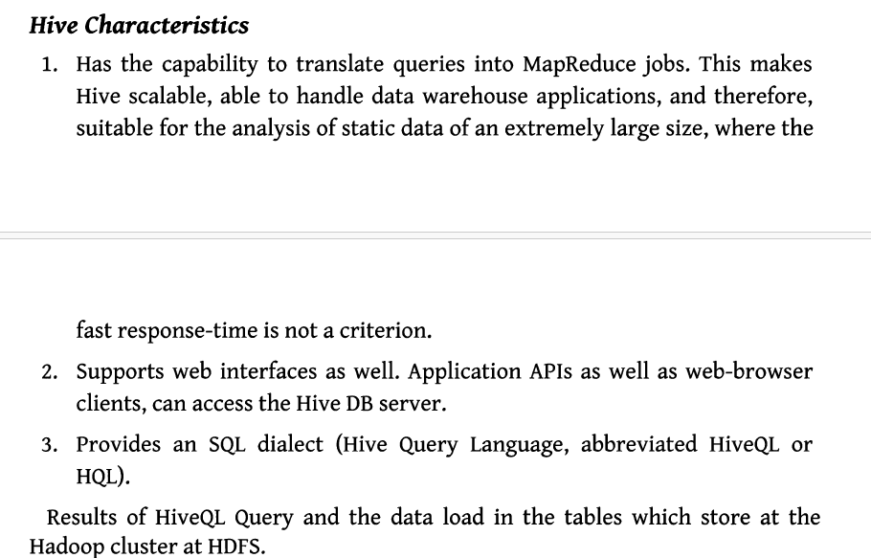

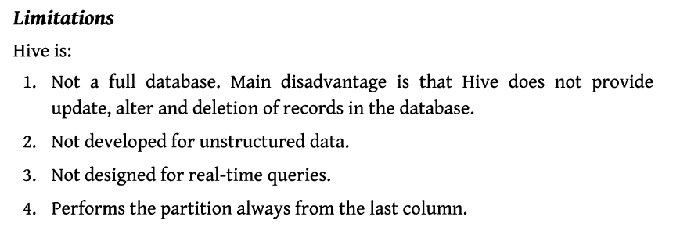

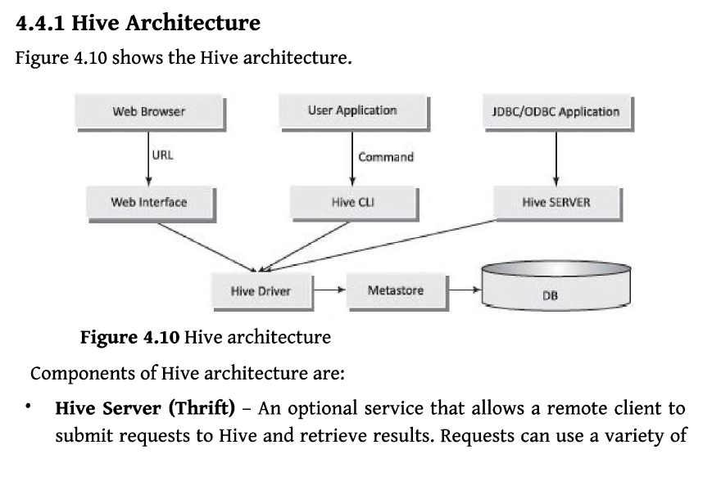

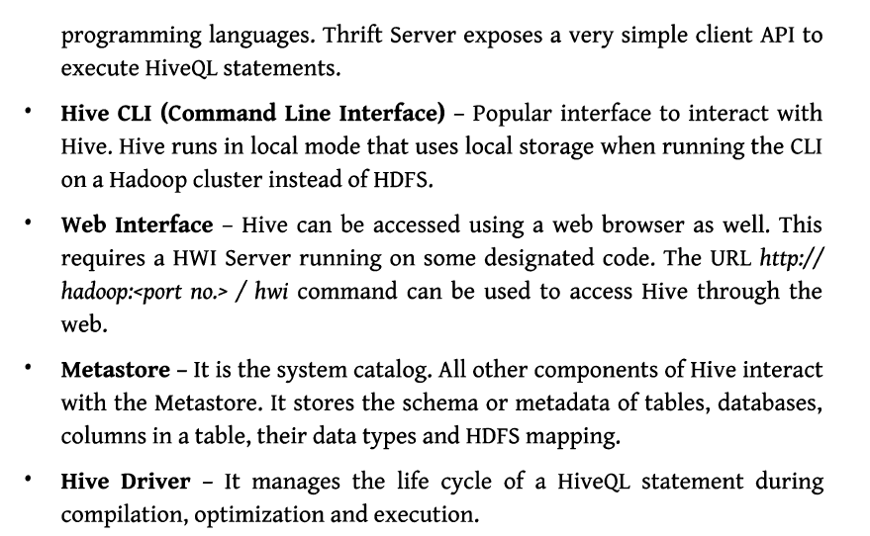

# Q) Hive QL

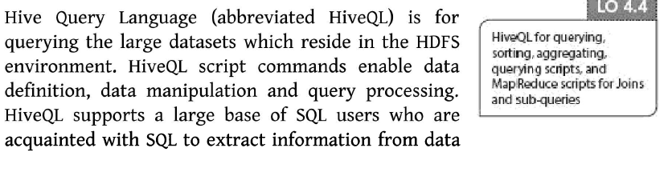

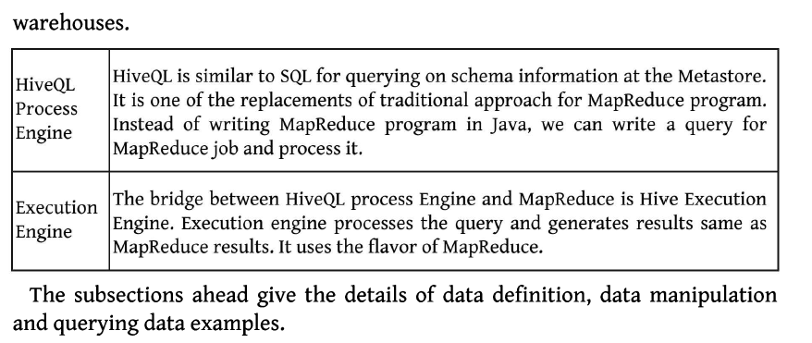

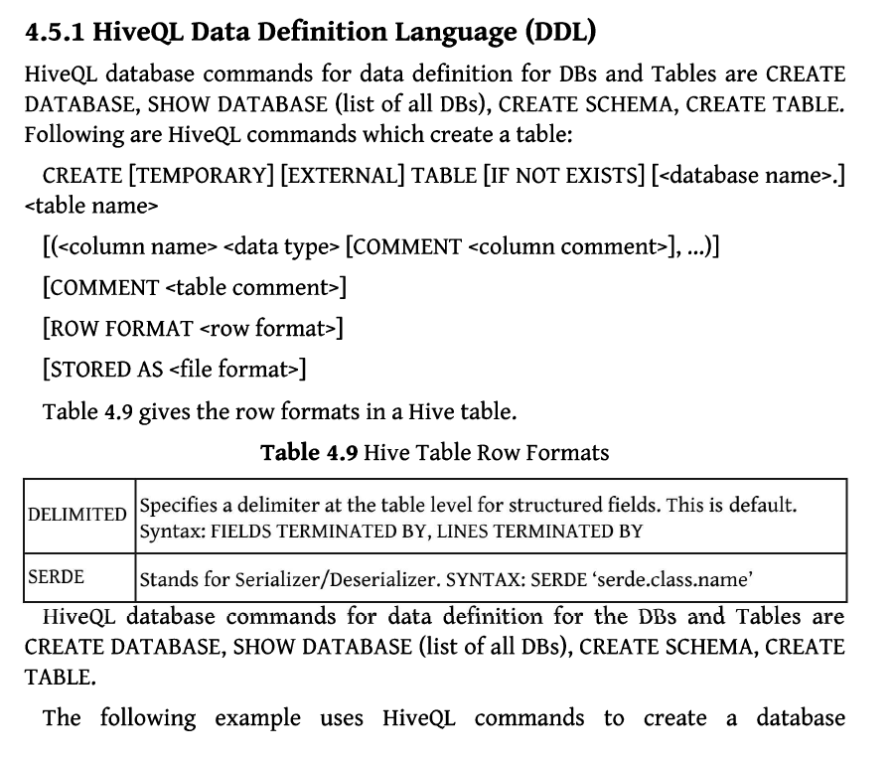

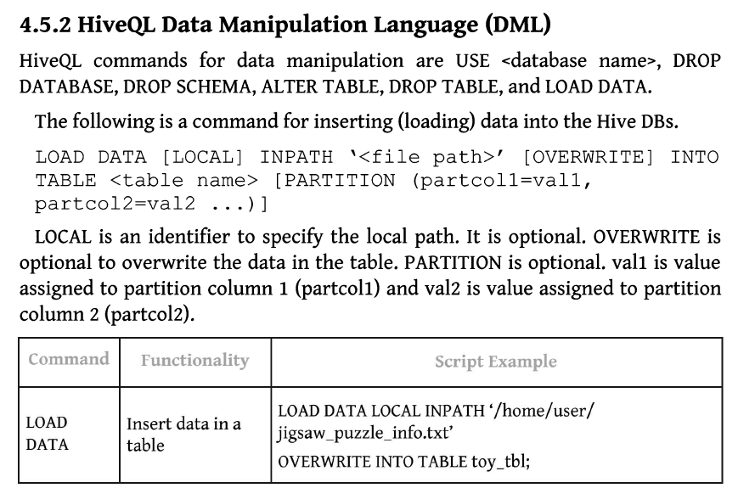

# Q) Pig

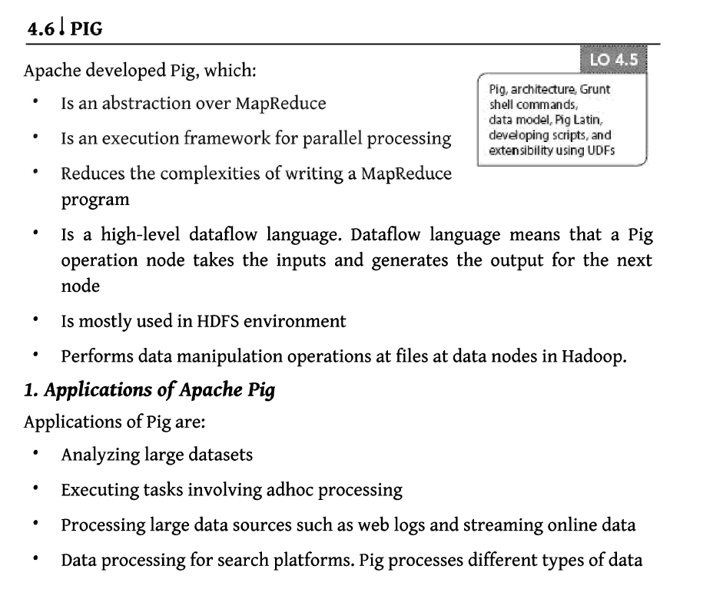

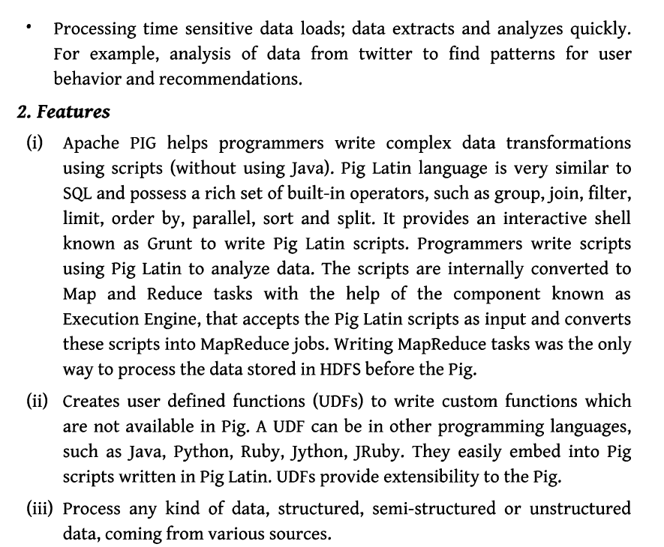

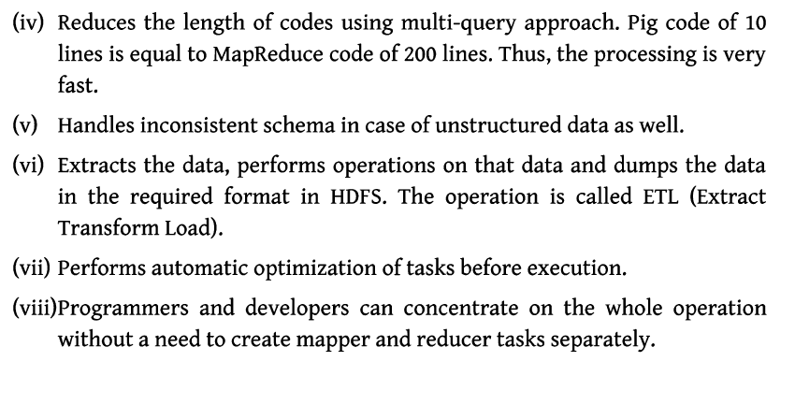

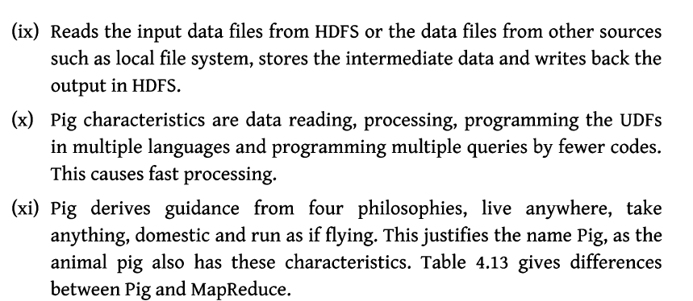

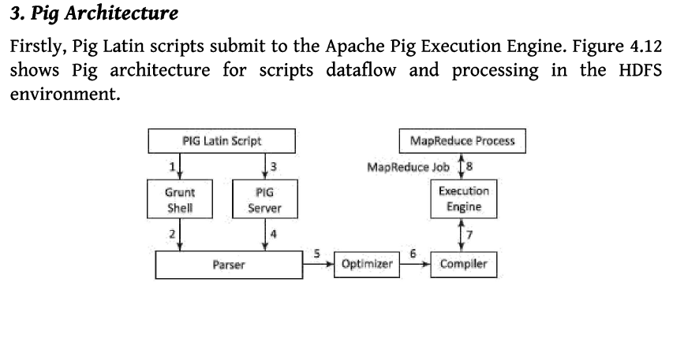

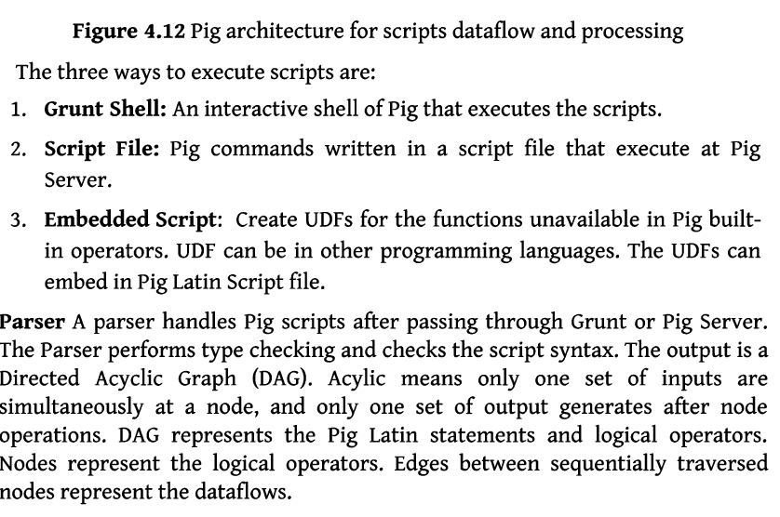

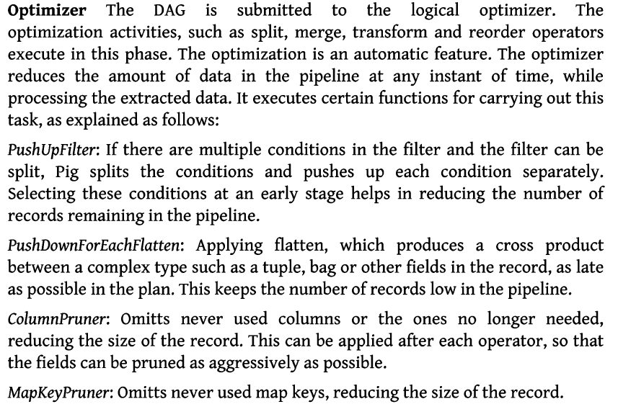

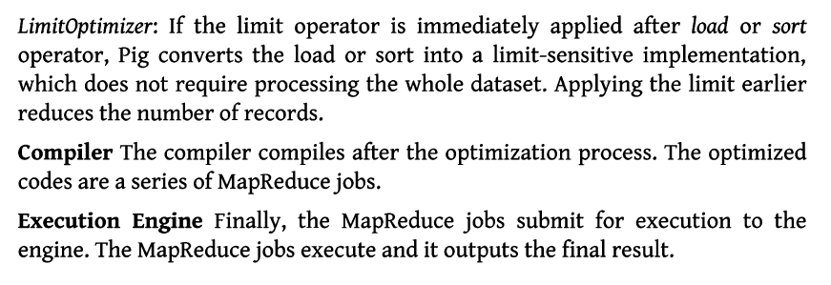

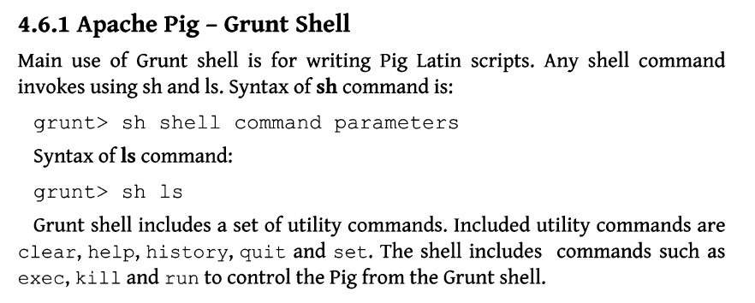

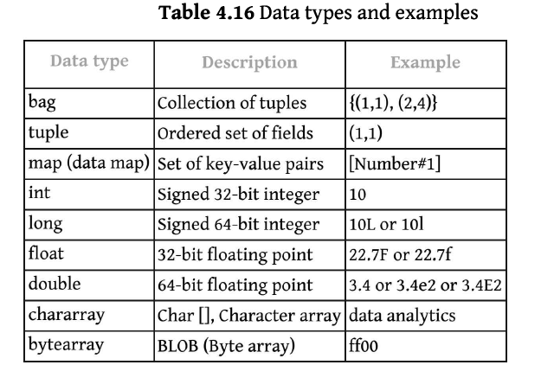

UNIT -IV

# Q) RDDs

**Q) What is RDD? Explain the features of RDD.**

RDDs are most essential part of the PySpark or we can say **backbone of PySpark.**

"Resilient Distributed Datasets (RDD) is a distributed memory abstraction that helps a programmer to perform in-memory computations on large cluster." One of the important advantages of RDD is **fault tolerance,** it means if any failure occurs it recovers automatically.

RDD divides data into smaller parts based on a key. The benefit of dividing data into smaller chunks is that if one executor node fails, another node will still process the data. These are able to recover quickly from any issues as the same data chunks are replicated across multiple executor nodes.

It provides the functionality to perform functional calculation against dataset very quickly by binding the multiple nodes.

RDD becomes immutable when it is created. Immutable mean, we cannot modify an object once it created, but it can surely be transforme.

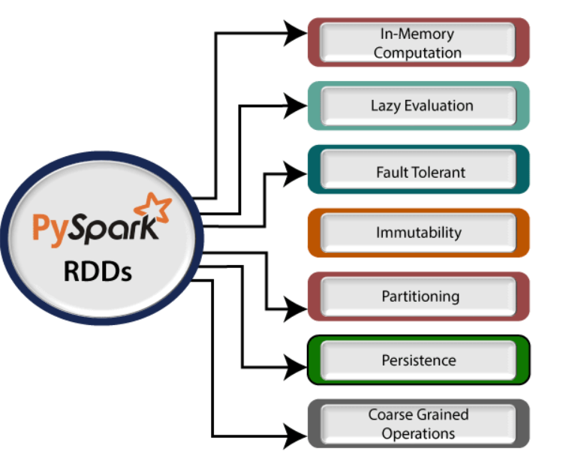

There are various advantages/features of using RDD. Some of them are

**1. In-memory computation:** Basically, while storing data in RDD, data isstored in memory for as long as you want to store. It improves the performance by an order of magnitudes by keeping the data in memory.

**2. Lazy Evaluation:** Spark Lazy Evaluation means the data inside RDDs arenot evaluated on the go. Basically, only after an action triggers all the changes or the computation is performed. Therefore, it limits how much work it has to do.

**3. Fault Tolerance:** If any worker node fails, by using lineage of operations,we can re-compute the lost partition of RDD from the original one. Hence, it is possible to recover lost data easily.

**4. Immutability:** Immutability means once we create an RDD, we can notmanipulate it. Moreover, we can create a new RDD by performing any transformation. Also, we achieve consistency through immutability.

**5.Persistence:** In in-memory, we can store the frequently used RDD. Also,we can retrieve them directly from memory without going to disk. It results in the speed of the execution. Moreover, we can perform multiple operations on the same data. It is only possible by storing the data explicitly in memory by calling persist() or cache() function.

**6. Partitioning:** Basically, RDD partition the records logically. Also,distributes the data across various nodes in the cluster. Moreover, the logical divisions are only for processing and internally it has no division. Hence, it provides parallelism.

7. **Parallel:** While we talk about parallel processing, RDD processes the data parallelly over the cluster.

**8. Location-Stickiness:** To compute partitions, RDDs are capable ofdefining placement preference. Moreover, placement preference refers to information about the location of RDD. Although, the DAGScheduler places the partitions in such a way that task is close to data as much as possible. Moreover, it speeds up computation.

**9. Coarse-grained Operation:** Generally, we apply coarse-grainedtransformations to Spark RDD. It means the operation applies to the whole dataset not on the single element in the data set of RDD in Spark.

**10. No limitation:** There are no limitations to use the number of SparkRDD. We can use any no. of RDDs. Basically, the limit depends on the size of disk and memory.

**Spark RDDs:**

**1. Parallelized collections** By invoking parallelize method in the driver program, we can create parallelized collections.

**scala:** scala>val rd1 = spark.sparkContext.parallelize(Seq(1,3,3))

scala> rd1.collect() res: Array[Int] = Array(1, 3, 3)

**2. External datasets** One can create Spark RDDs, by calling a textFile method. Hence, this method takes URL of the file and reads it as a collection of lines. Eg. lines = sc.textFile("README.txt")



With RDDs, you can perform two types of operations:

1. **Transformations:** They are the operations that are applied to create a newRDD.

2. **Actions:** They are applied on an RDD to instruct Apache Spark to applycomputation and pass the result back to the driver.

To summarize, every Spark program and shell session will work as follows:

1. Create some input RDDs from external data.

2. Transform them to define new RDDs using transformations like filter().

3. Ask Spark to persist() any intermediate RDDs that will need to be reused.

4. Launch actions such as count() and first() to kick off a parallel computation, which is then optimized and executed by Spark.

A **DataFrame** in PySpark is a distributed collection of structured data, organized into rows and columns, similar to a table in a relational database or a dataframe in Pandas. PySpark's DataFrame API is designed to be similar to the Pandas DataFrame but with the added benefit of being distributed and scalable for big data applications.

**Key Features of PySpark DataFrame:**

1. **Schema Information**: Each DataFrame has a schema, which defines the column names and types.
2. **Lazy Evaluation**: Transformations on DataFrames are not executed immediately; they are recorded as a DAG (Directed Acyclic Graph) and executed only upon an action.
3. **Distributed**: DataFrames are distributed across a cluster, enabling parallel processing.
4. **Integration**: It supports various file formats like JSON, CSV, Parquet, ORC, etc.

RDD

from pyspark.sql import SparkSession

# Initialize SparkSession

spark = SparkSession.builder.appName("DataFrameExample").getOrCreate()

# Create an RDD

rdd = spark.sparkContext.parallelize([(1, "Alice", 29), (2, "Bob", 35), (3, "Cathy", 45)])

# Define schema

from pyspark.sql.types import StructType, StructField, IntegerType, StringType

schema = StructType([

StructField("id", IntegerType(), True),

StructField("name", StringType(), True),

StructField("age", IntegerType(), True)

])

# Create DataFrame

df = spark.createDataFrame(rdd, schema)

df.show()

# Q) Spark SQL

Spark SQL is a core module of Apache Spark designed for working with structured and semi-structured data using a SQL-like interface. It integrates seamlessly with Spark's programming API to provide a unified analytics engine capable of querying data using SQL as well as manipulating it programmatically.

**Key Features of Spark SQL**

1. **Unified Data Access**  
   Spark SQL allows access to various data sources such as Hive tables, Parquet files, JSON files, JDBC data sources, and more. This enables developers to work with diverse datasets in a consistent way.
2. **Schema-Based Processing**  
   Unlike traditional RDDs, Spark SQL operates on structured data with a defined schema. This enables optimizations and allows easy access using familiar SQL-like syntax.
3. **SQL Queries**  
   Spark SQL supports standard SQL queries that are translated into Spark operations. This allows developers and analysts familiar with SQL to use Spark effectively without learning a new API.
4. **Integration with Spark Core**  
   Spark SQL is tightly integrated with Spark Core, enabling it to leverage Spark's distributed processing capabilities for large-scale data analysis.
5. **Catalyst Optimizer**  
   Spark SQL uses the Catalyst optimizer, an advanced query optimizer that converts logical query plans into optimized physical query plans. This ensures efficient execution of queries.
6. **Support for DataFrames and Datasets**  
   Spark SQL introduced the concept of DataFrames and Datasets, offering a more developer-friendly abstraction for working with structured data.

**Advantages of Spark SQL**

1. **Ease of Use**:  
   Analysts can use SQL queries, while developers can utilize Spark’s programming languages (Python, Scala, Java, R).
2. **Performance**:  
   Spark SQL offers significant performance benefits due to optimizations like columnar storage and predicate pushdown.
3. **Interoperability**:  
   It enables interoperability between SQL and Spark’s API, providing flexibility to mix SQL queries and complex analytical operations.
4. **Compatibility with BI Tools**:  
   Spark SQL integrates with popular Business Intelligence (BI) tools, such as Tableau, Power BI, and Apache Superset, enabling visualization of data processed by Spark.

**Components of Spark SQL**

1. **DataFrame API**:  
   DataFrames are distributed collections of data organized into named columns. They provide a higher-level abstraction than RDDs, enabling SQL-like operations.
2. **SQL Interface**:  
   Spark SQL supports running queries either through SQL strings or programmatically using the DataFrame API.
3. **Catalyst Optimizer**:  
   A key component of Spark SQL that optimizes query execution plans using logical and physical optimization techniques.

Creating a DataFrame and Querying with SQL

from pyspark.sql import SparkSession

# Initialize Spark Session

spark = SparkSession.builder.appName("SparkSQLExample").getOrCreate()

# Sample data

data = [(1, "Alice", 29), (2, "Bob", 35), (3, "Cathy", 45)]

columns = ["id", "name", "age"]

# Create DataFrame

df = spark.createDataFrame(data, schema=columns)

# Register DataFrame as a temporary SQL table

df.createOrReplaceTempView("people")

# Run an SQL query

result = spark.sql("SELECT name, age FROM people WHERE age > 30")

result.show()

# Q) Pyspark

To evaluate Spark SQL at a higher cognitive level, we need to critically assess its capabilities, compare it with alternatives, and determine its overall significance in the big data ecosystem. Below is a detailed evaluation.

**1. Critical Analysis of Spark SQL**

Spark SQL is a powerful module within Apache Spark designed to handle structured and semi-structured data at scale. By offering an SQL interface combined with Spark's distributed computing capabilities, it bridges the gap between data engineers and analysts.

**Strengths:**

* **Unified Approach:** Spark SQL enables users to query diverse data sources (JSON, Parquet, Hive, JDBC) using SQL, which is widely known and accepted in the industry.
* **Performance Optimizations:** Its **Catalyst Optimizer** ensures efficient query execution by applying logical and physical optimizations.
* **Flexibility:** The integration of SQL with programmatic APIs (DataFrame and Dataset) provides versatility. Developers can switch seamlessly between SQL queries and custom transformations.
* **Scalability:** Spark SQL processes large datasets distributed across a cluster, leveraging Spark’s in-memory computation for high-speed analytics.

**Weaknesses:**

* **Complex Configurations:** Setting up Spark SQL for optimal performance often requires tuning cluster settings, which might be challenging for beginners.
* **Latency for Small Data:** For smaller datasets, the overhead of distributed processing might lead to slower query execution compared to lightweight alternatives like Pandas.

**2. Comparison with Alternatives**

| **Feature** | **Spark SQL** | **Apache Hive** | **Presto/Trino** |
| --- | --- | --- | --- |
| **Performance** | High (in-memory, Catalyst) | Moderate (disk I/O) | High (optimized for queries) |
| **Ease of Use** | SQL + API integration | SQL-based | SQL-based |
| **Integration** | Python, Scala, Java, R | Limited | Limited |
| **Support for Data Formats** | Extensive (JSON, Parquet, ORC, Avro) | Moderate | Moderate |

**Evaluation:**

* Spark SQL outperforms traditional tools like Apache Hive in terms of speed and flexibility due to its in-memory processing.
* Compared to Presto, Spark SQL is more versatile as it integrates with a broader set of programming languages and supports complex transformations.

**3. Real-World Applications**

Spark SQL has found widespread adoption across industries:

**Use Case 1: Financial Analytics**

Banks and financial institutions use Spark SQL to process massive datasets (e.g., transactions, risk metrics) in near real-time for fraud detection and compliance.

**Use Case 2: E-commerce**

E-commerce companies analyze customer behavior, sales trends, and inventory data using Spark SQL's ability to query structured data at scale.

**Use Case 3: Healthcare**

Healthcare providers leverage Spark SQL for data analysis on patient records, medical images, and treatment patterns, facilitating better diagnostics and research.

**4. Future Potential**

The evolving nature of big data tools and the increasing need for real-time analytics indicate a bright future for Spark SQL. Features like **Data Lakehouse integration** (via Delta Lake) and compatibility with **BI tools** ensure its relevance in next-gen data platforms.

Q) Numpy

**NumPy** is a fundamental Python library for numerical computing, offering powerful tools for working with arrays and performing mathematical operations. At Bloom's Level 5 (Evaluating), we assess NumPy's strengths, weaknesses, applications, and future potential, supported by a practical example to illustrate its capabilities.

**1. Critical Analysis of NumPy**

**Strengths:**

1. **Performance**: NumPy is optimized for fast numerical computations, outperforming Python lists due to its C-based implementation and efficient memory management.
2. **Array Manipulation**: NumPy provides extensive operations for slicing, reshaping, and broadcasting, which simplify complex data processing tasks.
3. **Mathematical Operations**: Includes robust functionality for linear algebra, Fourier transforms, and statistical analysis.
4. **Interoperability**: Forms the foundation for many Python libraries like Pandas, SciPy, and TensorFlow, ensuring seamless integration.
5. **Ease of Use**: Despite its advanced capabilities, NumPy maintains a straightforward API for common tasks.

**Weaknesses:**

1. **Memory Constraints**: Operations are limited by available system memory, making it less suitable for extremely large datasets without distributed frameworks.
2. **No Native GPU Support**: While highly efficient on CPUs, NumPy lacks built-in GPU acceleration, restricting its use in high-performance computing scenarios.

**2. Applications of NumPy**

**Use Case 1: Machine Learning**

NumPy supports matrix operations, crucial for training models and implementing algorithms like gradient descent.

**Use Case 2: Data Preprocessing**

With capabilities like standardization, normalization, and handling missing values, NumPy simplifies data preparation for machine learning pipelines.

**Use Case 3: Simulation**

In scientific computing, NumPy is used for simulating processes such as Monte Carlo methods or particle dynamics.

**3. Practical Example: Solving a System of Linear Equations**

Consider the system of linear equations:  
2x+3y=82x + 3y = 82x+3y=8  
3x+y=53x + y = 53x+y=5

Using NumPy, this can be solved efficiently:

import numpy as np

# Coefficient matrix (A) and constant matrix (B)

A = np.array([[2, 3], [3, 1]])

B = np.array([8, 5])

# Solving for x and y

solution = np.linalg.solve(A, B)

# Output the solution

print("Solution:", solution)

Output

Solution: [1. 2.]

**5. Conclusion**

NumPy is a cornerstone library for numerical and scientific computing in Python. Its unparalleled performance for CPU-based operations, wide range of functionalities, and compatibility with other libraries ensure its dominance. While it has limitations in scaling for distributed or GPU-accelerated tasks, NumPy continues to serve as the foundation for Python's data science and machine learning frameworks.

Q) Scipy

**SciPy** is a Python library built on top of NumPy that provides additional functionality for scientific computing. It is widely used for optimization, integration, interpolation, linear algebra, statistics, and signal processing.

**Features of SciPy**

1. **Optimization**: Functions to solve optimization problems (e.g., minimizing or maximizing mathematical functions).
2. **Integration**: Tools for numerical integration and solving differential equations.
3. **Linear Algebra**: Advanced linear algebra operations, including eigenvalues and matrix decompositions.
4. **Statistics**: Statistical tests, distributions, and probability functions.
5. **Signal and Image Processing**: Tools for filtering, Fourier transforms, and signal analysis.
6. **Sparse Matrix Support**: Efficient operations on sparse matrices.

**Advantages of SciPy**

1. **Comprehensive**: Covers a wide range of scientific computing needs.
2. **Extends NumPy**: Leverages NumPy arrays and provides additional functionality.
3. **Optimized Performance**: Written in C, making it efficient for numerical operations.
4. **Open Source**: Free to use with a large, active community for support.

**Disadvantages of SciPy**

1. **Learning Curve**: Advanced modules can be challenging for beginners.
2. **Memory Limitations**: Constrained by available memory for very large datasets.
3. **No GPU Support**: Unlike some modern libraries, SciPy does not support GPU acceleration.

**Example Program: Numerical Integration Using SciPy**

Suppose we want to compute the definite integral of the function f(x)=x2f(x) = x^2f(x)=x2 from 0 to 5.

**Program:**

from scipy.integrate import quad

# Define the function to integrate

def func(x):

return x**2

# Perform numerical integration

result, error = quad(func, 0, 5)

# Display the result

print(f"Integral result: {result}")

print(f"Estimated error: {error}")

Output

Integral result: 41.66666666666667

Estimated error: 4.625929269271485e-13

**Explanation of the Example**

* **quad**: A function from the SciPy integration module that computes definite integrals.
* **func(x)**: Defines the function x2x^2x2.
* **Integration**: Calculates the area under the curve of x2x^2x2 from 0 to 5 with high precision.

**Conclusion**

SciPy is an essential library for advanced scientific and numerical tasks. Its features like optimization, integration, and signal processing make it a powerful extension of NumPy. However, its lack of GPU support might limit its use in modern, high-performance computing scenarios. For most applications in research and industry, SciPy remains a reliable and efficient tool.

# Q) Code Optimization in Pyspark

**1. Optimize Data Serialization**

* **Preferred Format**: Use **Kryo Serialization** instead of default Java serialization for faster and more compact serialization.

from pyspark import SparkConf, SparkContext

conf = SparkConf().set("spark.serializer", "org.apache.spark.serializer.KryoSerializer")

sc = SparkContext(conf=conf)

**2. Minimize Data Shuffling**

* **Shuffling** occurs during operations like groupByKey, join, or distinct. To reduce shuffles:
  + Use **reduceByKey** instead of groupByKey for aggregations.
  + Prefer **map-side aggregations** by combining data locally before shuffling.

# Avoid groupByKey

rdd = sc.parallelize([("a", 1), ("b", 1), ("a", 1)])

reduced = rdd.reduceByKey(lambda x, y: x + y)

**3. Use DataFrames and Spark SQL**

* DataFrames and Spark SQL leverage the **Catalyst Optimizer** for efficient query execution.

from pyspark.sql import SparkSession

spark = SparkSession.builder.appName("OptimizationExample").getOrCreate()

# Example

data = [("Alice", 30), ("Bob", 35), ("Alice", 28)]

df = spark.createDataFrame(data, ["Name", "Age"])

df.groupBy("Name").avg("Age").show()

4. **Partitioning Strategies**

* Optimize partitioning to balance workload across the cluster:
  + Use **repartition** to increase partitions for large datasets.
  + Use **coalesce** to reduce partitions for smaller datasets to avoid unnecessary overhead.

df = df.repartition(10) # Increase partitions

df = df.coalesce(2) # Reduce partitions

# Q) Cluster Configuration

**1. Executor Memory and Cores**

* **Configuration**:
  + spark.executor.memory: Memory allocated to each executor.
  + spark.executor.cores: Cores allocated to each executor.
* **Purpose**: Controls the computational and memory resources for each executor, crucial for parallel execution.

**Example:**

--executor-memory 4g --executor-cores 4

**2. Driver Memory**

* **Configuration**:
  + spark.driver.memory: Memory allocated to the driver.
* **Purpose**: Ensures the driver has enough memory for task scheduling and coordination.

**Example:**

--driver-memory 2g

**3. Number of Executors**

* **Configuration**:
  + spark.executor.instances: Specifies the number of executors.
* **Purpose**: Defines how many executors run in parallel, increasing overall parallelism.

**Example:**

--num-executors 10

**. Dynamic Resource Allocation**

* **Configuration**:
  + spark.dynamicAllocation.enabled: Enables or disables dynamic resource allocation.
  + spark.dynamicAllocation.minExecutors and spark.dynamicAllocation.maxExecutors: Set bounds for the number of executors.
* **Purpose**: Automatically adjusts the number of executors based on the workload.

**Example:**

--conf spark.dynamicAllocation.enabled=true \

--conf spark.dynamicAllocation.minExecutors=2 \

--conf spark.dynamicAllocation.maxExecutors=20

**5. Shuffle Partitions**

* **Configuration**:
  + spark.sql.shuffle.partitions: Sets the number of partitions used during shuffle operations.
* **Purpose**: Controls parallelism during operations like groupBy, join, and distinct, optimizing performance by adjusting partition size.

**Example:**

--conf spark.sql.shuffle.partitions=200

Q) Linear algebra computations in large scale

Linear algebra forms the foundation of many machine learning, data analysis, and computational tasks. Handling large-scale linear algebra computations efficiently is a significant challenge due to the size of data and the complexity of operations. In distributed computing environments like **PySpark**, **Hadoop**, and **MPI**, linear algebra computations can be performed at scale by leveraging parallelization and optimized algorithms. Here's a detailed analysis of linear algebra computations at large scale, covering techniques, tools, and optimization methods.

**Distributed Computing for Linear Algebra**

Large-scale linear algebra computations typically require distributing the data and computations across multiple machines to speed up processing. Key distributed frameworks used for linear algebra computations are:

* **Apache Spark (PySpark)**: Spark's MLlib and DataFrames offer built-in functions for linear algebra operations that can be parallelized across a cluster of machines.
* **Dask**: Dask provides parallel computing for Python, supporting scalable arrays and matrices. Dask’s array module allows users to work with large matrices across distributed systems.
* **MPI (Message Passing Interface)**: MPI is widely used in high-performance computing (HPC) and enables communication between different processes to solve large linear algebra problems in parallel.

**Example with PySpark:**

from pyspark.ml.linalg import Vectors

from pyspark.sql import SparkSession

spark = SparkSession.builder.appName("LinearAlgebraExample").getOrCreate()

# Create a DataFrame with vectors (rows of matrices)

data = [(1, Vectors.dense([1.0, 2.0, 3.0])),

(2, Vectors.dense([4.0, 5.0, 6.0]))]

df = spark.createDataFrame(data, ["ID", "Features"])

# Perform matrix operations like dot product, transpose, etc.

# Q) Distributed File Storage System

**Distributed File Storage System**

A distributed file storage system is crucial for handling large-scale data storage and processing in distributed computing environments like PySpark. PySpark, being built on top of Apache Spark, leverages distributed file storage systems like HDFS (Hadoop Distributed File System), Amazon S3,Google Cloud Storage, and other cloud-based solutions to handle data across multiple machines.

Why Use a Distributed File System in PySpark?

1. Scalability: Handles petabytes of data by distributing it across many nodes.
2. Fault Tolerance: Replicates data blocks across nodes, ensuring availability even in case of hardware failures.
3. Data Locality: Minimizes network overhead by processing data close to where it is stored.
4. Integration: PySpark seamlessly integrates with popular DFSs like HDFS, S3, and Azure.
5. Support for Big Data Formats: Supports formats like Parquet, ORC, and Avro optimized for big data workflows.

How PySpark Interacts with DFS

1. Input Stage: PySpark reads data stored in a DFS and loads it into RDDs or DataFrames for processing.
2. Processing Stage: The distributed nature of the DFS ensures efficient data access for PySpark’s parallel processing.
3. Output Stage: Processed results are written back to the DFS for persistent storage.

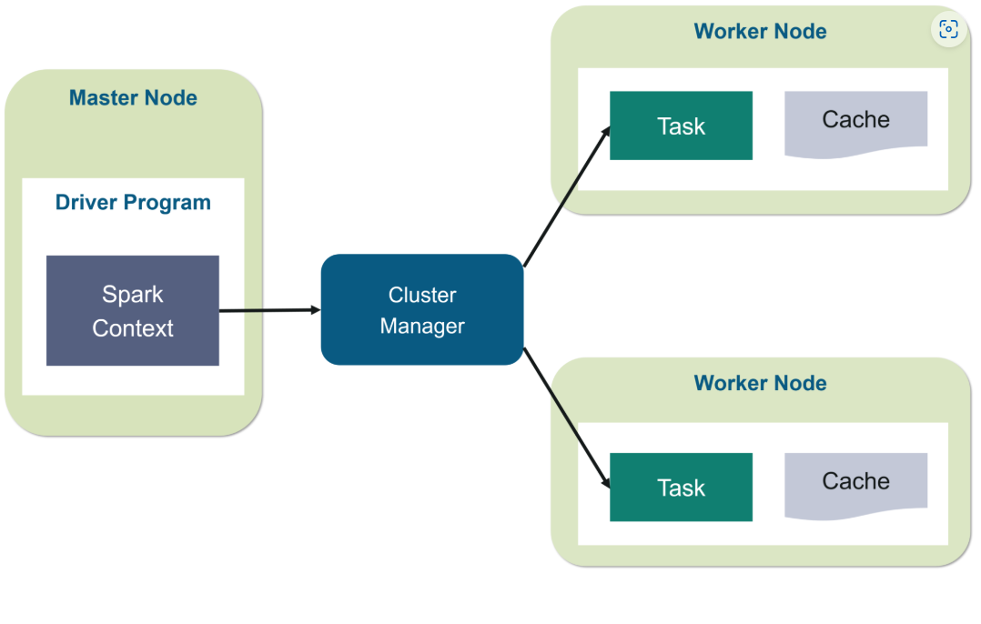

Reading and Writing Data from HDFS in PySpark

from pyspark.sql import SparkSession

# Initialize Spark session

spark = SparkSession.builder \

.appName("HDFS Integration Example") \

.getOrCreate()

# Reading data from HDFS (CSV file)

df = spark.read.csv("hdfs://namenode_host:9000/user/hadoop/data/input.csv", header=True)

#Show the dataframe

df.show()

# Writing data back to HDFS (Parquet format)

df.write.parquet("hdfs://namenode_host:9000/user/hadoop/data/output.parquet")

UNIT -V

# Q) Basic Statistics

Correlation

Calculating the correlation between two series of data is a common operation in Statistics. In spark.ml we provide the flexibility to calculate pairwise correlations among many series. The supported correlation methods are currently Pearson’s and Spearman’s correlation.

Hypothesis testing

Hypothesis testing is a powerful tool in statistics to determine whether a result is statistically significant, whether this result occurred by chance or not. spark.ml currently supports Pearson’s Chi-squared ( χ2) tests for independence.

ChiSquareTest

ChiSquareTest conducts Pearson’s independence test for every feature against the label. For each feature, the (feature, label) pairs are converted into a contingency matrix for which the Chi-squared statistic is computed. All label and feature values must be categorical.

Summarizer We provide vector column summary statistics for Dataframe through Summarizer. Available metrics are the column-wise max, min, mean, sum, variance, std, and number of nonzeros, as well as the total count.

Spark ML Program for basic statistics

from pyspark.sql import SparkSession

from pyspark.sql.functions import col, mean, stddev, variance, max, min, count, countDistinct

import numpy as np

# Initialize Spark session

spark = SparkSession.builder \

.appName("Basic Statistics with PySpark") \

.getOrCreate()

# Sample Data: Create a DataFrame with sample data

data = [(1, 'A'), (2, 'B'), (3, 'A'), (4, 'B'), (5, 'A'), (6, 'B')]

columns = ["Value", "Category"]

df = spark.createDataFrame(data, columns)

# Show the DataFrame

df.show()

# 1. Calculate Mean

mean_value = df.select(mean("Value")).collect()[0][0]

print(f"Mean: {mean_value}")

# 2. Calculate Median (Approximated)

sorted_df = df.orderBy("Value")

median_value = sorted_df.collect()[len(sorted_df)//2]["Value"]

print(f"Median: {median_value}")

# 3. Mode Calculation (Using DataFrame groupBy and count)

mode_value = df.groupBy("Value").count().orderBy("count", ascending=False).first()[0]

print(f"Mode: {mode_value}")

# 4. Calculate Variance

variance_value = df.select(variance("Value")).collect()[0][0]

print(f"Variance: {variance_value}")

# 5. Calculate Standard Deviation

std_dev_value = df.select(stddev("Value")).collect()[0][0]

print(f"Standard Deviation: {std_dev_value}")

# 6. Calculate Range (Max - Min)

min_value = df.select(min("Value")).collect()[0][0]

max_value = df.select(max("Value")).collect()[0][0]

range_value = max_value - min_value

print(f"Range: {range_value}")

# 7. Probability: Calculate probability of a certain event (e.g., Probability of 'A' in Category)

category_count = df.groupBy("Category").count().collect()

total_count = len(df.collect())

category_prob = {row['Category']: row['count'] / total_count for row in category_count}

print(f"Probability of each category: {category_prob}")

# 8. Hypothesis Testing: Check if the mean of 'Value' is equal to 3

# Null hypothesis H0: Mean(Value) = 3

from pyspark.ml.stat import ChiSquareTest

from pyspark.ml.linalg import Vectors

from pyspark.sql import Row

# Create a new DataFrame for hypothesis testing (We can assume the data to be normal for simplicity)

test_data = [(1.0,), (2.0,), (3.0,), (4.0,), (5.0,)]

test_columns = ["Value"]

test_df = spark.createDataFrame(test_data, test_columns)

# Performing Chi-Square Test (basic test for independence in categorical data)

# Here, we simulate testing the distribution of a column

rdd = test_df.rdd.map(lambda x: Vectors.dense(x)).toDF(["features"])

# Conducting the test on the created features

result = ChiSquareTest.test(rdd, "features", "Value").head()

print(f"Chi-Square Test: {result.pValue}")

# Stop the Spark session

spark.stop()

# Q) Data Sources

n this section, we introduce how to use data source in ML to load data. Besides some general data sources such as Parquet, CSV, JSON and JDBC, we also provide some specific data sources for ML.

**Table of Contents**

* [Image data source](https://spark.apache.org/docs/3.5.1/ml-datasource.html#image-data-source)
* [LIBSVM data source](https://spark.apache.org/docs/3.5.1/ml-datasource.html#libsvm-data-source)

Image data source

This image data source is used to load image files from a directory, it can load compressed image (jpeg, png, etc.) into raw image representation via ImageIO in Java library. The loaded DataFrame has one StructType column: “image”, containing image data stored as image schema. The schema of the image column is:

* origin: StringType (represents the file path of the image)
* height: IntegerType (height of the image)
* width: IntegerType (width of the image)
* nChannels: IntegerType (number of image channels)
* mode: IntegerType (OpenCV-compatible type)
* data: BinaryType (Image bytes in OpenCV-compatible order: row-wise BGR in most cases)

LIBSVM data source

This LIBSVM data source is used to load ‘libsvm’ type files from a directory. The loaded DataFrame has two columns: label containing labels stored as doubles and features containing feature vectors stored as Vectors. The schemas of the columns are:

* label: DoubleType (represents the instance label)
* features: VectorUDT (represents the feature vector)

Q) Pipeline

Pipeline

In machine learning, it is common to run a sequence of algorithms to process and learn from data. E.g., a simple text document processing workflow might include several stages:

* Split each document’s text into words.
* Convert each document’s words into a numerical feature vector.
* Learn a prediction model using the feature vectors and labels.

MLlib represents such a workflow as a Pipeline, which consists of a sequence of PipelineStages (Transformers and Estimators) to be run in a specific order. We will use this simple workflow as a running example in this section.

A Pipeline is specified as a sequence of stages, and each stage is either a Transformer or an Estimator. These stages are run in order, and the input DataFrame is transformed as it passes through each stage. For Transformer stages, the transform() method is called on the DataFrame. For Estimator stages, the fit() method is called to produce a Transformer (which becomes part of the PipelineModel, or fitted Pipeline), and that Transformer’s transform() method is called on the DataFrame.

We illustrate this for the simple text document workflow. The figure below is for the *training time* usage of a Pipeline.

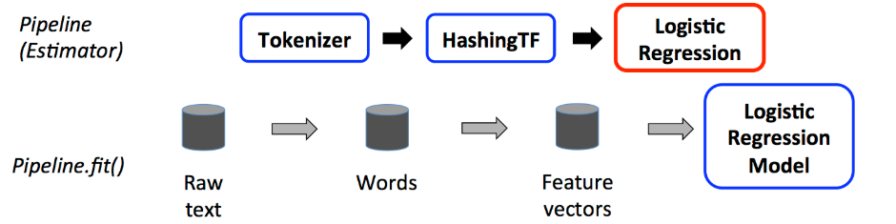

Above, the top row represents a Pipeline with three stages. The first two (Tokenizer and HashingTF) are Transformers (blue), and the third (LogisticRegression) is an Estimator (red). The bottom row represents data flowing through the pipeline, where cylinders indicate DataFrames. The Pipeline.fit() method is called on the original DataFrame, which has raw text documents and labels. The Tokenizer.transform() method splits the raw text documents into words, adding a new column with words to the DataFrame. The HashingTF.transform() method converts the words column into feature vectors, adding a new column with those vectors to the DataFrame. Now, since LogisticRegression is an Estimator, the Pipeline first calls LogisticRegression.fit() to produce a LogisticRegressionModel. If the Pipeline had more Estimators, it would call the LogisticRegressionModel’s transform() method on the DataFrame before passing the DataFrame to the next stage.

A Pipeline is an Estimator. Thus, after a Pipeline’s fit() method runs, it produces a PipelineModel, which is a Transformer. This PipelineModel is used at *test time*; the figure below illustrates this usage.

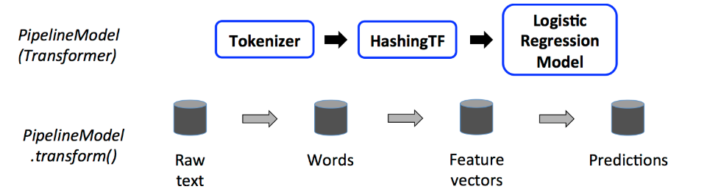

In the figure above, the PipelineModel has the same number of stages as the original Pipeline, but all Estimators in the original Pipeline have become Transformers. When the PipelineModel’s transform() method is called on a test dataset, the data are passed through the fitted pipeline in order. Each stage’s transform() method updates the dataset and passes it to the next stage.

# Q) Extracting, transforming and selecting features

Feature Extractor

Word2Vec is an Estimator which takes sequences of words representing documents and trains a Word2VecModel. The model maps each word to a unique fixed-size vector. The Word2VecModel transforms each document into a vector using the average of all words in the document; this vector can then be used as features for prediction, document similarity calculations, etc. Please refer to the [MLlib user guide on Word2Vec](https://spark.apache.org/docs/3.5.1/mllib-feature-extraction.html#word2vec) for more details.

[Feature Transformers](https://spark.apache.org/docs/3.5.1/ml-features.html#feature-transformers)

[PCA](http://en.wikipedia.org/wiki/Principal_component_analysis) is a statistical procedure that uses an orthogonal transformation to convert a set of observations of possibly correlated variables into a set of values of linearly uncorrelated variables called principal components. A [PCA](https://spark.apache.org/docs/3.5.1/api/scala/org/apache/spark/ml/feature/PCA.html) class trains a model to project vectors to a low-dimensional space using PCA. The example below shows how to project 5-dimensional feature vectors into 3-dimensional principal components.

**from** **pyspark.ml.feature** **import** PCA

**from** **pyspark.ml.linalg** **import** Vectors

data = [(Vectors.sparse(5, [(1, 1.0), (3, 7.0)]),),

(Vectors.dense([2.0, 0.0, 3.0, 4.0, 5.0]),),

(Vectors.dense([4.0, 0.0, 0.0, 6.0, 7.0]),)]

df = spark.createDataFrame(data, ["features"])

pca = PCA(k=3, inputCol="features", outputCol="pcaFeatures")

model = pca.fit(df)

result = model.transform(df).select("pcaFeatures")

result.show(truncate=False)

Selecting Feature

ChiSqSelector

ChiSqSelector stands for Chi-Squared feature selection. It operates on labeled data with categorical features. ChiSqSelector uses the [Chi-Squared test of independence](https://en.wikipedia.org/wiki/Chi-squared_test) to decide which features to choose. It supports five selection methods: numTopFeatures, percentile, fpr, fdr, fwe:

* numTopFeatures chooses a fixed number of top features according to a chi-squared test. This is akin to yielding the features with the most predictive power.
* percentile is similar to numTopFeatures but chooses a fraction of all features instead of a fixed number.
* fpr chooses all features whose p-values are below a threshold, thus controlling the false positive rate of selection.
* fdr uses the [Benjamini-Hochberg procedure](https://en.wikipedia.org/wiki/False_discovery_rate#Benjamini.E2.80.93Hochberg_procedure) to choose all features whose false discovery rate is below a threshold.
* fwe chooses all features whose p-values are below a threshold. The threshold is scaled by 1/numFeatures, thus controlling the family-wise error rate of selection. By default, the selection method is numTopFeatures, with the default number of top features set to 50. The user can choose a selection method using setSelectorType.

**Examples**

Assume that we have a DataFrame with the columns id, features, and clicked, which is used as our target to be predicted:

id | features | clicked

---|-----------------------|---------

7 | [0.0, 0.0, 18.0, 1.0] | 1.0

8 | [0.0, 1.0, 12.0, 0.0] | 0.0

9 | [1.0, 0.0, 15.0, 0.1] | 0.0

If we use ChiSqSelector with numTopFeatures = 1, then according to our label clicked the last column in our features is chosen as the most useful feature:

id | features | clicked | selectedFeatures

---|-----------------------|---------|------------------

7 | [0.0, 0.0, 18.0, 1.0] | 1.0 | [1.0]

8 | [0.0, 1.0, 12.0, 0.0] | 0.0 | [0.0]

9 | [1.0, 0.0, 15.0, 0.1] | 0.0 | [0.1]

Q) Classification & Regression

# Decision tree classifier

Decision trees are a popular family of classification and regression methods. More information about the spark.ml implementation can be found further in the [section on decision trees](https://spark.apache.org/docs/3.5.1/ml-classification-regression.html#decision-trees).

Classification Example

The following examples load a dataset in LibSVM format, split it into training and test sets, train on the first dataset, and then evaluate on the held-out test set. We use two feature transformers to prepare the data; these help index categories for the label and categorical features, adding metadata to the DataFrame which the Decision Tree algorithm can recognize.

**from** **pyspark.ml** **import** Pipeline

**from** **pyspark.ml.classification** **import** DecisionTreeClassifier

**from** **pyspark.ml.feature** **import** StringIndexer, VectorIndexer

**from** **pyspark.ml.evaluation** **import** MulticlassClassificationEvaluator

*# Load the data stored in LIBSVM format as a DataFrame.*

data = spark.read.format("libsvm").load("data/mllib/sample_libsvm_data.txt")

*# Index labels, adding metadata to the label column.*

*# Fit on whole dataset to include all labels in index.*

labelIndexer = StringIndexer(inputCol="label", outputCol="indexedLabel").fit(data)

*# Automatically identify categorical features, and index them.*

*# We specify maxCategories so features with > 4 distinct values are treated as continuous.*

featureIndexer =\

VectorIndexer(inputCol="features", outputCol="indexedFeatures", maxCategories=4).fit(data)

*# Split the data into training and test sets (30% held out for testing)*

(trainingData, testData) = data.randomSplit([0.7, 0.3])

*# Train a DecisionTree model.*

dt = DecisionTreeClassifier(labelCol="indexedLabel", featuresCol="indexedFeatures")

*# Chain indexers and tree in a Pipeline*

pipeline = Pipeline(stages=[labelIndexer, featureIndexer, dt])

*# Train model. This also runs the indexers.*

model = pipeline.fit(trainingData)

*# Make predictions.*

predictions = model.transform(testData)

*# Select example rows to display.*

predictions.select("prediction", "indexedLabel", "features").show(5)

*# Select (prediction, true label) and compute test error*

evaluator = MulticlassClassificationEvaluator(

labelCol="indexedLabel", predictionCol="prediction", metricName="accuracy")

accuracy = evaluator.evaluate(predictions)

**print**("Test Error = %g " % (1.0 - accuracy))

treeModel = model.stages[2]

*# summary only*

**print**(treeModel)

Regression Example

# Decision tree regression

Decision trees are a popular family of classification and regression methods. More information about the spark.ml implementation can be found further in the [section on decision trees](https://spark.apache.org/docs/3.5.1/ml-classification-regression.html#decision-trees).

**Examples**

The following examples load a dataset in LibSVM format, split it into training and test sets, train on the first dataset, and then evaluate on the held-out test set. We use a feature transformer to index categorical features, adding metadata to the DataFrame which the Decision Tree algorithm can recognize.

**from** **pyspark.ml** **import** Pipeline

**from** **pyspark.ml.regression** **import** DecisionTreeRegressor

**from** **pyspark.ml.feature** **import** VectorIndexer

**from** **pyspark.ml.evaluation** **import** RegressionEvaluator

*# Load the data stored in LIBSVM format as a DataFrame.*

data = spark.read.format("libsvm").load("data/mllib/sample_libsvm_data.txt")

*# Automatically identify categorical features, and index them.*

*# We specify maxCategories so features with > 4 distinct values are treated as continuous.*

featureIndexer =\

VectorIndexer(inputCol="features", outputCol="indexedFeatures", maxCategories=4).fit(data)

*# Split the data into training and test sets (30% held out for testing)*

(trainingData, testData) = data.randomSplit([0.7, 0.3])

*# Train a DecisionTree model.*

dt = DecisionTreeRegressor(featuresCol="indexedFeatures")

*# Chain indexer and tree in a Pipeline*

pipeline = Pipeline(stages=[featureIndexer, dt])

*# Train model. This also runs the indexer.*

model = pipeline.fit(trainingData)

*# Make predictions.*

predictions = model.transform(testData)

*# Select example rows to display.*

predictions.select("prediction", "label", "features").show(5)

*# Select (prediction, true label) and compute test error*

evaluator = RegressionEvaluator(

labelCol="label", predictionCol="prediction", metricName="rmse")

rmse = evaluator.evaluate(predictions)

**print**("Root Mean Squared Error (RMSE) on test data = %g" % rmse)

treeModel = model.stages[1]

*# summary only*

**print**(treeModel)

Q) Clustering

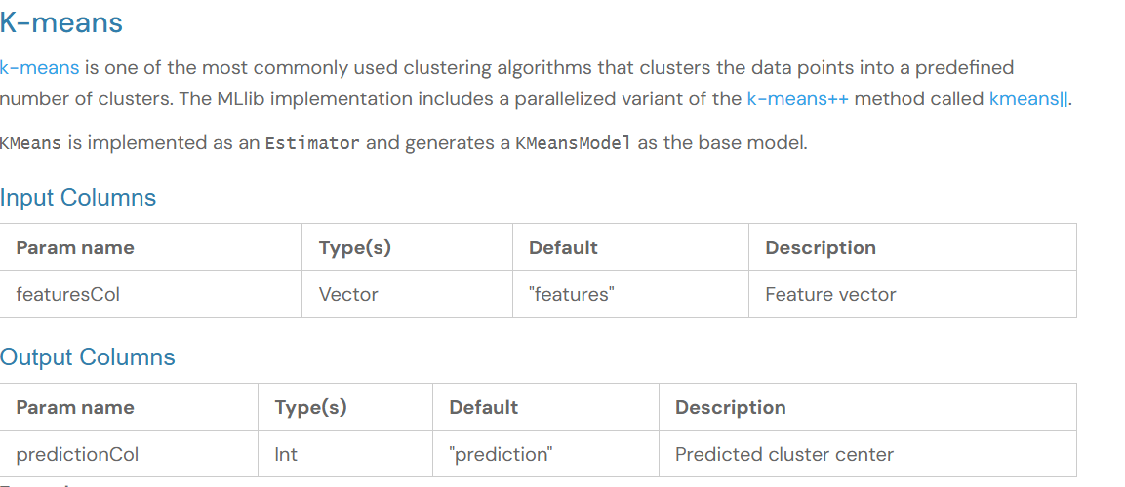

**from** **pyspark.ml.clustering** **import** KMeans

**from** **pyspark.ml.evaluation** **import** ClusteringEvaluator

*# Loads data.*

dataset = spark.read.format("libsvm").load("data/mllib/sample_kmeans_data.txt")

*# Trains a k-means model.*

kmeans = KMeans().setK(2).setSeed(1)

model = kmeans.fit(dataset)

*# Make predictions*

predictions = model.transform(dataset)

*# Evaluate clustering by computing Silhouette score*

evaluator = ClusteringEvaluator()

silhouette = evaluator.evaluate(predictions)

**print**("Silhouette with squared euclidean distance = " + str(silhouette))

*# Shows the result.*

centers = model.clusterCenters()

**print**("Cluster Centers: ")

**for** center **in** centers:

**print**(center)

# Q) Collaborative filtering

[Collaborative filtering](http://en.wikipedia.org/wiki/Recommender_system#Collaborative_filtering) is commonly used for recommender systems. These techniques aim to fill in the missing entries of a user-item association matrix. spark.ml currently supports model-based collaborative filtering, in which users and products are described by a small set of latent factors that can be used to predict missing entries. spark.ml uses the [alternating least squares (ALS)](http://dl.acm.org/citation.cfm?id=1608614) algorithm to learn these latent factors. The implementation in spark.ml has the following parameters:

* *numBlocks* is the number of blocks the users and items will be partitioned into in order to parallelize computation (defaults to 10).
* *rank* is the number of latent factors in the model (defaults to 10).
* *maxIter* is the maximum number of iterations to run (defaults to 10).
* *regParam* specifies the regularization parameter in ALS (defaults to 1.0).
* *implicitPrefs* specifies whether to use the *explicit feedback* ALS variant or one adapted for *implicit feedback* data (defaults to false which means using *explicit feedback*).
* *alpha* is a parameter applicable to the implicit feedback variant of ALS that governs the *baseline* confidence in preference observations (defaults to 1.0).
* *nonnegative* specifies whether or not to use nonnegative constraints for least squares (defaults to false).
* **from** **pyspark.ml.evaluation** **import** RegressionEvaluator
* **from** **pyspark.ml.recommendation** **import** ALS
* **from** **pyspark.sql** **import** Row
* lines = spark.read.text("data/mllib/als/sample_movielens_ratings.txt").rdd
* parts = lines.map(**lambda** row: row.value.split("::"))
* ratingsRDD = parts.map(**lambda** p: Row(userId=int(p[0]), movieId=int(p[1]),
* rating=float(p[2]), timestamp=int(p[3])))
* ratings = spark.createDataFrame(ratingsRDD)
* (training, test) = ratings.randomSplit([0.8, 0.2])
* *# Build the recommendation model using ALS on the training data*
* *# Note we set cold start strategy to 'drop' to ensure we don't get NaN evaluation metrics*
* als = ALS(maxIter=5, regParam=0.01, userCol="userId", itemCol="movieId", ratingCol="rating",
* coldStartStrategy="drop")
* model = als.fit(training)
* *# Evaluate the model by computing the RMSE on the test data*
* predictions = model.transform(test)
* evaluator = RegressionEvaluator(metricName="rmse", labelCol="rating",
* predictionCol="prediction")
* rmse = evaluator.evaluate(predictions)
* **print**("Root-mean-square error = " + str(rmse))
* *# Generate top 10 movie recommendations for each user*
* userRecs = model.recommendForAllUsers(10)
* *# Generate top 10 user recommendations for each movie*
* movieRecs = model.recommendForAllItems(10)
* *# Generate top 10 movie recommendations for a specified set of users*
* users = ratings.select(als.getUserCol()).distinct().limit(3)
* userSubsetRecs = model.recommendForUserSubset(users, 10)
* *# Generate top 10 user recommendations for a specified set of movies*
* movies = ratings.select(als.getItemCol()).distinct().limit(3)
* movieSubSetRecs = model.recommendForItemSubset(movies, 10)

Frequent Pattern Mining

Mining frequent items, itemsets, subsequences, or other substructures is usually among the first steps to analyze a large-scale dataset, which has been an active research topic in data mining for years. We refer users to Wikipedia’s [association rule learning](http://en.wikipedia.org/wiki/Association_rule_learning) for more information.

**Table of Contents**

* [FP-Growth](https://spark.apache.org/docs/3.5.1/ml-frequent-pattern-mining.html#fp-growth)
* [PrefixSpan](https://spark.apache.org/docs/3.5.1/ml-frequent-pattern-mining.html#prefixspan)

# Q) Frequent pattern Mining

FP-Growth

The FP-growth algorithm is described in the paper [Han et al., Mining frequent patterns without candidate generation](https://doi.org/10.1145/335191.335372), where “FP” stands for frequent pattern. Given a dataset of transactions, the first step of FP-growth is to calculate item frequencies and identify frequent items. Different from [Apriori-like](http://en.wikipedia.org/wiki/Apriori_algorithm) algorithms designed for the same purpose, the second step of FP-growth uses a suffix tree (FP-tree) structure to encode transactions without generating candidate sets explicitly, which are usually expensive to generate. After the second step, the frequent itemsets can be extracted from the FP-tree. In spark.mllib, we implemented a parallel version of FP-growth called PFP, as described in [Li et al., PFP: Parallel FP-growth for query recommendation](https://doi.org/10.1145/1454008.1454027). PFP distributes the work of growing FP-trees based on the suffixes of transactions, and hence is more scalable than a single-machine implementation. We refer users to the papers for more details.

FP-growth operates on *itemsets*. An itemset is an unordered collection of unique items. Spark does not have a *set* type, so itemsets are represented as arrays.

spark.ml’s FP-growth implementation takes the following (hyper-)parameters:

* minSupport: the minimum support for an itemset to be identified as frequent. For example, if an item appears 3 out of 5 transactions, it has a support of 3/5=0.6.
* minConfidence: minimum confidence for generating Association Rule. Confidence is an indication of how often an association rule has been found to be true. For example, if in the transactions itemset X appears 4 times, X and Y co-occur only 2 times, the confidence for the rule X => Y is then 2/4 = 0.5. The parameter will not affect the mining for frequent itemsets, but specify the minimum confidence for generating association rules from frequent itemsets.
* numPartitions: the number of partitions used to distribute the work. By default the param is not set, and number of partitions of the input dataset is used.

The FPGrowthModel provides:

* freqItemsets: frequent itemsets in the format of a DataFrame with the following columns:
  + items: array: A given itemset.
  + freq: long: A count of how many times this itemset was seen, given the configured model parameters.
* associationRules: association rules generated with confidence above minConfidence, in the format of a DataFrame with the following columns:
  + antecedent: array: The itemset that is the hypothesis of the association rule.
  + consequent: array: An itemset that always contains a single element representing the conclusion of the association rule.
  + confidence: double: Refer to minConfidence above for a definition of confidence.
  + lift: double: A measure of how well the antecedent predicts the consequent, calculated as support(antecedent U consequent) / (support(antecedent) x support(consequent))
  + support: double: Refer to minSupport above for a definition of support.
* transform: For each transaction in itemsCol, the transform method will compare its items against the antecedents of each association rule. If the record contains all the antecedents of a specific association rule, the rule will be considered as applicable and its consequents will be added to the prediction result. The transform method will summarize the consequents from all the applicable rules as prediction. The prediction column has the same data type as itemsCol and does not contain existing items in the itemsCol.

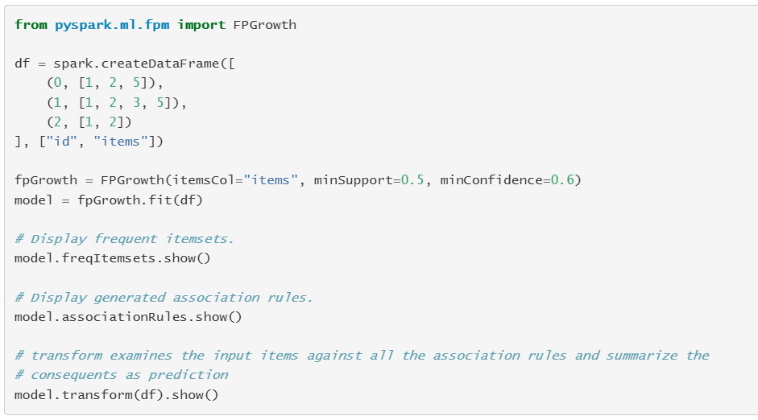

# Q) ML Tuning: model selection and hyperparameter tuning

This section describes how to use MLlib’s tooling for tuning ML algorithms and Pipelines. Built-in Cross-Validation and other tooling allow users to optimize hyperparameters in algorithms and Pipelines.

**Table of contents**

* [Model selection (a.k.a. hyperparameter tuning)](https://spark.apache.org/docs/3.5.1/ml-tuning.html#model-selection-aka-hyperparameter-tuning)
* [Cross-Validation](https://spark.apache.org/docs/3.5.1/ml-tuning.html#cross-validation)
* [Train-Validation Split](https://spark.apache.org/docs/3.5.1/ml-tuning.html#train-validation-split)

Model selection (a.k.a. hyperparameter tuning)

An important task in ML is *model selection*, or using data to find the best model or parameters for a given task. This is also called *tuning*. Tuning may be done for individual Estimators such as LogisticRegression, or for entire Pipelines which include multiple algorithms, featurization, and other steps. Users can tune an entire Pipeline at once, rather than tuning each element in the Pipeline separately.

MLlib supports model selection using tools such as [CrossValidator](https://spark.apache.org/docs/3.5.1/api/scala/org/apache/spark/ml/tuning/CrossValidator.html) and [TrainValidationSplit](https://spark.apache.org/docs/3.5.1/api/scala/org/apache/spark/ml/tuning/TrainValidationSplit.html). These tools require the following items:

* [Estimator](https://spark.apache.org/docs/3.5.1/api/scala/org/apache/spark/ml/Estimator.html): algorithm or Pipeline to tune
* Set of ParamMaps: parameters to choose from, sometimes called a “parameter grid” to search over
* [Evaluator](https://spark.apache.org/docs/3.5.1/api/scala/org/apache/spark/ml/evaluation/Evaluator.html): metric to measure how well a fitted Model does on held-out test data

At a high level, these model selection tools work as follows:

* They split the input data into separate training and test datasets.
* For each (training, test) pair, they iterate through the set of ParamMaps:
  + For each ParamMap, they fit the Estimator using those parameters, get the fitted Model, and evaluate the Model’s performance using the Evaluator.
* They select the Model produced by the best-performing set of parameters.

The Evaluator can be a [RegressionEvaluator](https://spark.apache.org/docs/3.5.1/api/scala/org/apache/spark/ml/evaluation/RegressionEvaluator.html) for regression problems, a [BinaryClassificationEvaluator](https://spark.apache.org/docs/3.5.1/api/scala/org/apache/spark/ml/evaluation/BinaryClassificationEvaluator.html) for binary data, a [MulticlassClassificationEvaluator](https://spark.apache.org/docs/3.5.1/api/scala/org/apache/spark/ml/evaluation/MulticlassClassificationEvaluator.html) for multiclass problems, a [MultilabelClassificationEvaluator](https://spark.apache.org/docs/3.5.1/api/scala/org/apache/spark/ml/evaluation/MultilabelClassificationEvaluator.html) for multi-label classifications, or a [RankingEvaluator](https://spark.apache.org/docs/3.5.1/api/scala/org/apache/spark/ml/evaluation/RankingEvaluator.html) for ranking problems. The default metric used to choose the best ParamMap can be overridden by the setMetricName method in each of these evaluators.

To help construct the parameter grid, users can use the [ParamGridBuilder](https://spark.apache.org/docs/3.5.1/api/scala/org/apache/spark/ml/tuning/ParamGridBuilder.html) utility. By default, sets of parameters from the parameter grid are evaluated in serial. Parameter evaluation can be done in parallel by setting parallelism with a value of 2 or more (a value of 1 will be serial) before running model selection with CrossValidator or TrainValidationSplit. The value of parallelism should be chosen carefully to maximize parallelism without exceeding cluster resources, and larger values may not always lead to improved performance. Generally speaking, a value up to 10 should be sufficient for most clusters.

Cross-Validation

CrossValidator begins by splitting the dataset into a set of *folds* which are used as separate training and test datasets. E.g., with k=3k=3 folds, CrossValidator will generate 3 (training, test) dataset pairs, each of which uses 2/3 of the data for training and 1/3 for testing. To evaluate a particular ParamMap, CrossValidator computes the average evaluation metric for the 3 Models produced by fitting the Estimator on the 3 different (training, test) dataset pairs.

After identifying the best ParamMap, CrossValidator finally re-fits the Estimator using the best ParamMap and the entire dataset.

**Examples: model selection via cross-validation**

The following example demonstrates using CrossValidator to select from a grid of parameters.

Note that cross-validation over a grid of parameters is expensive. E.g., in the example below, the parameter grid has 3 values for hashingTF.numFeatures and 2 values for lr.regParam, and CrossValidator uses 2 folds. This multiplies out to (3×2)×2=12(3×2)×2=12 different models being trained. In realistic settings, it can be common to try many more parameters and use more folds (k=3k=3 and k=10k=10 are common). In other words, using CrossValidator can be very expensive. However, it is also a well-established method for choosing parameters which is more statistically sound than heuristic hand-tuning.